



Cherry Gazpacho

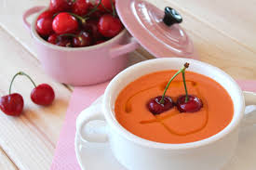
Ingredients
1 kilo of ripe tomatoes
25 grams of onion
10 grams of green pepper
1/2 clove of garlic
80 grams of extra virgin olive oil
10 grams of apple cider vinegar
200 grams of cherries
Salt
Preparation
1. We wash and we pit the cherries. We put everything in the glass of the blender.
2. We wash the tomatoes, the onion and the pepper and we chop them. We add everything to the glass of the blender with half garlic clove and the salt.
3. We beat at full power for a few minutes.
4. When everything is well crushed, we add the oil and the vinegar little by little, while we continue beating, in this way the liquid parts and the solid parts are not separated in the mixture. When everything is well beaten we add water.
5 We put the mixture in a strainer so that it remains without lumps.
6. We reserve in the fridge.
Enjoy your meal!

