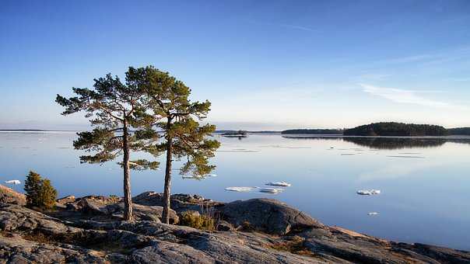
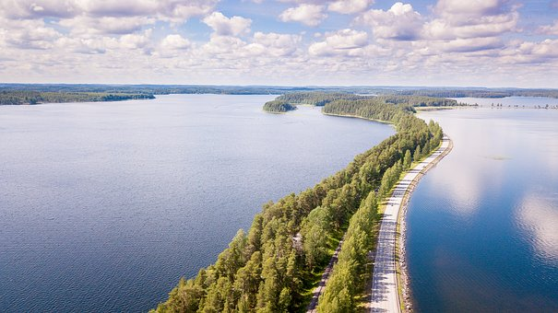

I like…..
- considerate people
- sauna
- pure nature
- Santa Claus
- fairness
- honesty
- weather
- safety
- Finnish food
- various hobby opportunities
- the animals are family members
- ice hockey
- everyone has the right to go to school
- language
- peaceful
- equality
- Finns are nice and good people
- clean tap water
- animal´s rights
- woods
- children´s rights
- tradition
- seasons
- Winter Sports
- school lunch
- good health care
- independency
- there are no natural disasters
- Finns are calm

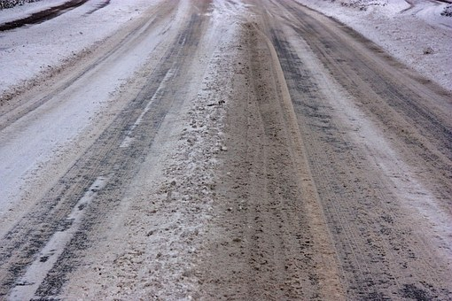

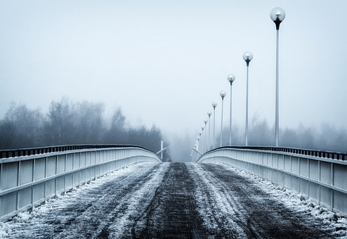

I dislike…..
- frost
- darkness
- mosquitoes
- Finns do not talk easily to strangers
- bad weather
- abuse of alcohol
- introversion
- some Finns are rude
- Finns are shy
- prejudices towards foreigners because there aren’t many of them in Finland
- sports fanatics, sport is too important ( e.g. ice hockey)
- people are too calm, it’s not easy to get them excited about new things

