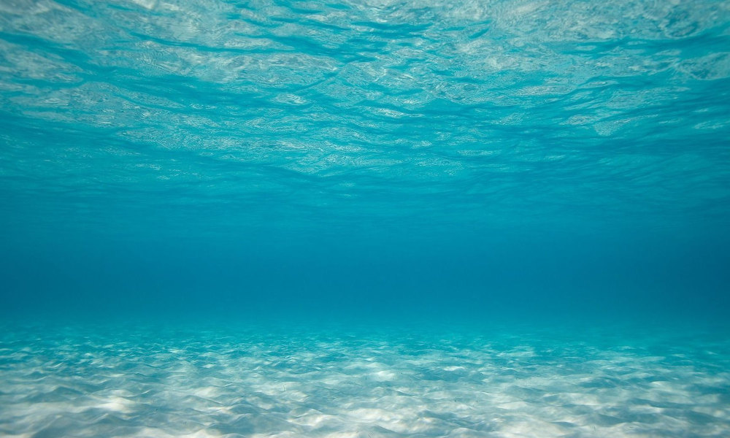
Save water!

3 ways to save water:

-Take quick baths
-Close the tap tightly
-Brush the teeth with the tap off

3 ways to protect the ocean:

-Take care of the beaches
-Support an organization that protects marine life
-Do not use disposable cups, or plastic cutlery

Please contribute to save our planet!!!

