
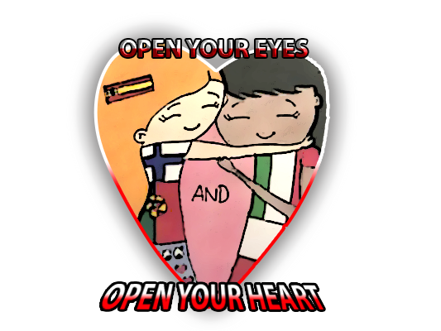


PEER EDUCATION

In San Bartolomé school we are developing cooperative learning in our lessons. In cooperative learning, students work together in pairs or small groups on a structured activity. They are individually accountable for their work, and the work of the pairs or groups as a whole is also assessed. Cooperative pairs work face-to-face and learn to work as a team. Skillful students help low basic skills students and both get a profit.
In small groups or pairs students can share strengths and also develop their weaker skills. They develop their interpersonal skills. They learn to deal with conflict. When cooperative tasks are guided by clear objectives, students engage in numerous activities that improve their understanding of subjects explored.
In order to create an environment in which cooperative learning can take place, three things are necessary. First, students need to feel safe, but also challenged. Second, groups need to be small enough that everyone can contribute. Third, the task students work together on must be clearly defined. The cooperative and collaborative learning techniques presented here should help make this possible for teachers.
An example of cooperative activity is Round Robin or Pencils in the Centre. This activity is very useful for knowledge-building in which students interact with each other to review contents they have learned before. They read some questions ans answer them orally. In this time, it is time to listen ans speak, so they put their pencils in the middle of the table. They can not write the answer in their worksheets. Once they have finished talking and everyone knows what they have to do, it is time to hold their pencils and start writing. They enjoy this activity a lot!

