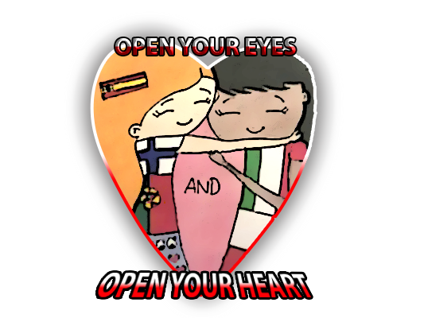

I think I wanna help you

It's a beautiful day,
we're looking for something good to do
Hey there, I think I wanna help you
So come and open your eyes,
And then let’s open our hearts!
It’s fun, it is! I think I wanna help you!

Porque es un buen momento
Si quieres yo te espero
Vamos oh oh oh
Juntos tú y yo oh oh
Nos esperan

Porque es un buen momento
Si quieres yo te espero
Vamos oh oh oh
Juntos tú y yo oh oh
Nos esperan

Don't say no no no no no
Just say yeah yeah yeah yeah yeah
And we'll go go go go go
If you're ready, like I'm ready

'Cause It's a beautiful day,
we're looking for something good to do
Hey there, I think I wanna help you
So come and open your eyes,
And then let’s open our hearts!
It’s fun, it is! I think I wanna help you!
Oh
Hai bisogno di me – non mi chiedo il
Perché – eee ooh – e allora che
Facciaaaamooo – dai! andiamoooo
Obudzeni być nie chcemy razem,
no cóż.
Nie Twoja wina
było cudnie.

Don't say no no no no no
Just say yeah yeah yeah yeah yeah
And we'll go go go go go
If you're ready, like I'm ready

'Cause It's a beautiful day,
we're looking for something good to do
Hey there, I think I wanna help you
So come and open your eyes,
And then let’s open our hearts!
It’s fun, it is! I think I wanna help you!

Just say I do
Tell me right now baby
Tell me right now baby, baby
Just say I do
Tell me right now baby
Tell me right now baby, baby
Oh

It's a beautiful day,
we're looking for something good to do
Hey there, I think I wanna help you
So come and open your eyes,
And then let’s open our hearts!
It’s fun, it is! I think I wanna help you!

