The Ocean

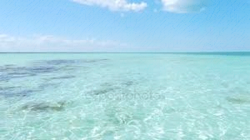
Needs Us!

We need to help the biggest source of water in the world!
And to help the ocean, seas and rivers we need to do something about it|
Here are some tips to help the ocean :
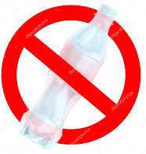
- Don't throw out the garbage on the beach.
- If you see any garbage in the ocean, or on the beach, catch it and put it in the garbage can.
- Recycle.
For factories :
- Don't throw your chemicals into the river, please!
For Freighters, fishing boats and all boats in general :
- Be very careful with the oil leakage.
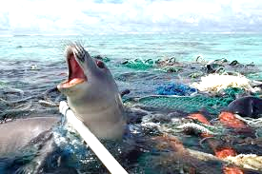
For all Governments :
- Please, appreciate that we only have one big Ocean and create laws to help it becoming clean !!!

