Cold Blueberry Soup - A Recipe from Finland

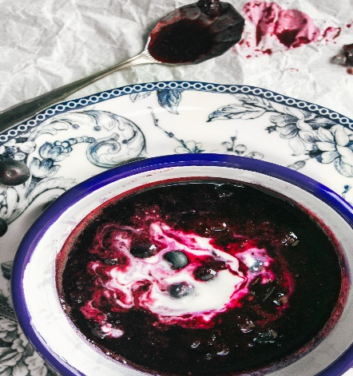

Preparation time: 30 mins
Cook time: 10 mins
Total time: 40 mins
Serves: 1

Ingredients
- 1.5 cups / 225 grams blueberries
- ¾ cups water
- 1 tsp lemon juice
- ½ tsp cinnamon
- ¼ cardamon
- Pinch of salt

Method
- Bring water, blueberries, lemon juice, cinnamon, salt and cardamon to boil in a small sauce pan
- Reduce to low-medium heat and let it simmer for 10 min
- Remove pan from stove and mash most of the blueberries using a fork
- Let it cool to room temperature or put it in the fridge for 30-60 min
- Serve cold or at room temperature in a bowl with rice pudding, porridge, coconut cream or whatever you like! In Finland we traditionally serve it with rice pudding.

