Spinach Pancakes

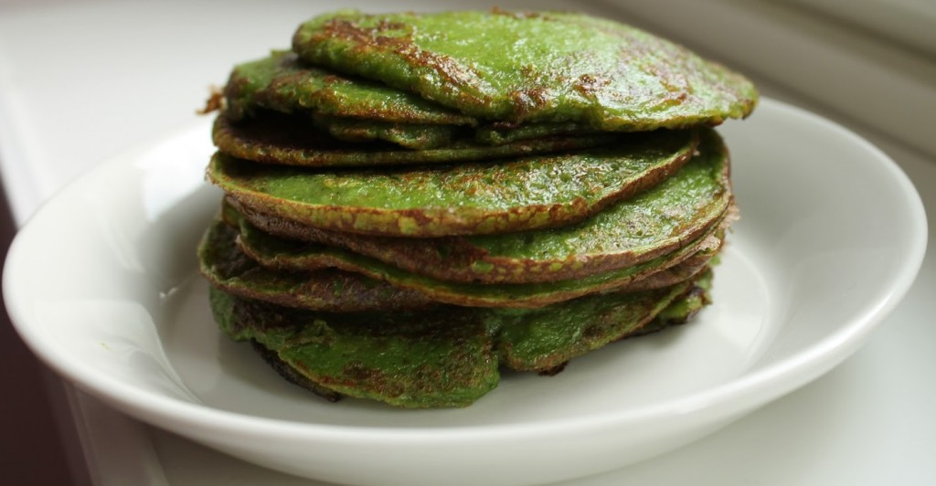

the Ingredients
- 2 1/2 cups of fresh baby spinach (frozen is OK if fresh spinach is not available)
- 500ml of milk
- 2 eggs
- 1/2 teaspoon salt
- 1 tablespoon of Baking Soda
- 1 cup of wholewheat flour
- 1 1/2 cups of all-purpose flour
- 1 tablespoon of Olive Oil / Vegetable Oil
- Butter or Oil for cooking the pancakes
- Berry Jam (lingonberry, cranberry, gooseberry) for serving

the Instructions
- Wash and drain the fresh baby spinach if needed
- Puree the spinach with the milk in a blender
- Pour into mixing bowl and whisk in the eggs, salt, oil and flour until you have a smooth batter
- Warm up the frying pan (medium heat) and lightly grease with butter or oil
- Make any size pancakes you want
- Place a soup ladle full of batter in the pan and cook until the wet side of the pancake bubbles (usually about 2-3 minutes)
- Flip and cook the other side for 2-3 minutes until lightly brown
- Serve warm with jam

