High hand:
X(t)=5.859x² -1.018x- 2.564
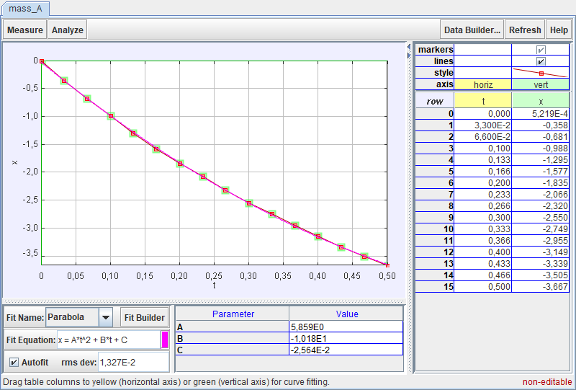
V(t)=-1.114x²+1.734x-1.074
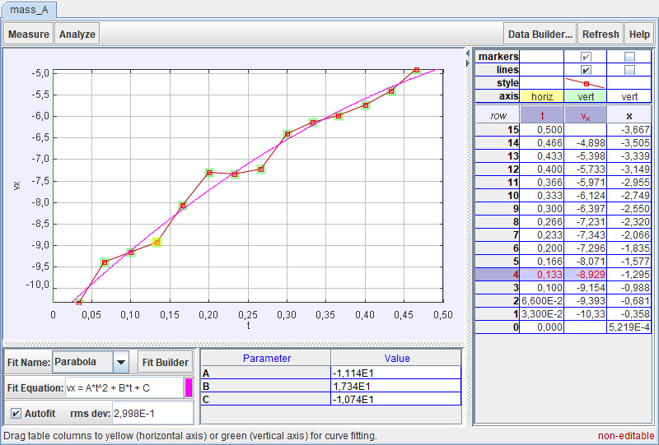

Low hand:
X(t)=4.228x²- 8.328x-2.914
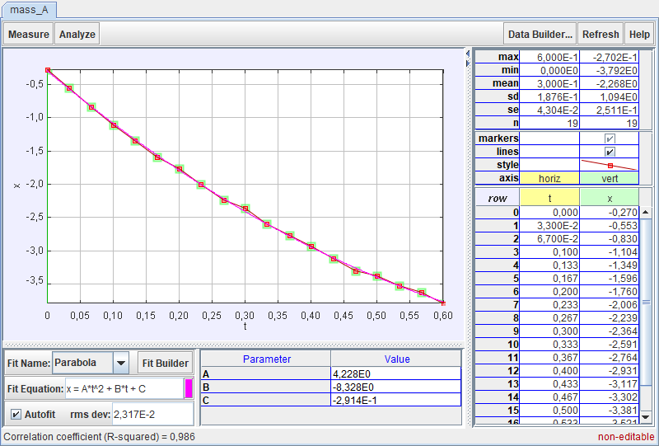
V(t)=… our graphic indicates the wrong numbers...
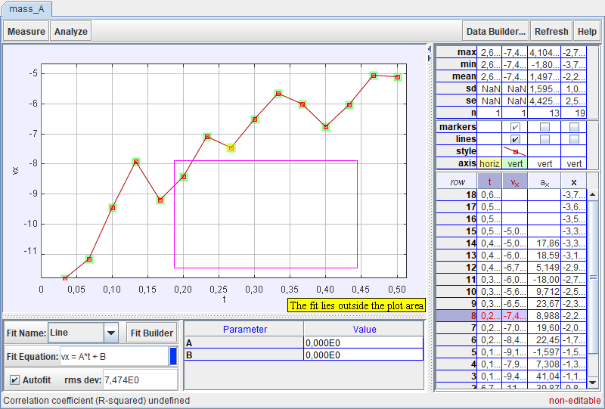

Jump:
X(t)=6.305x²-1.080x-1.315
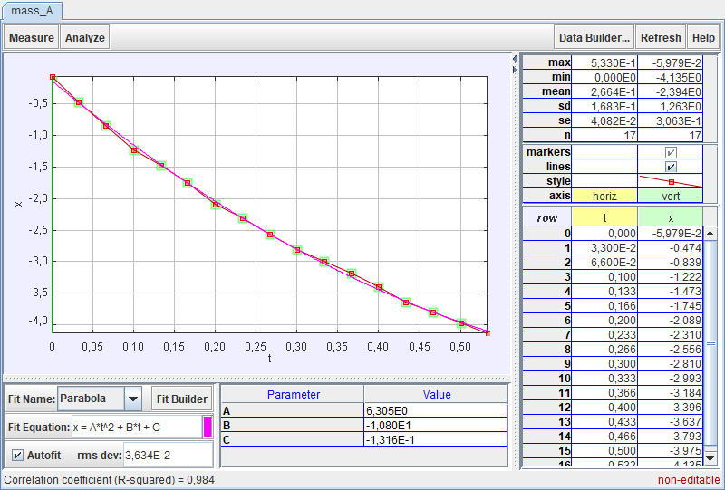
V(t)=8.911x - 8.932
