Auto-Evaluation Report
First year of Erasmus Plus Project
“Water Around Us”

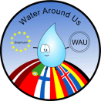

Isabel Castro
(Agrupamento de Escolas de Valongo - Portugal)
June 2015

CONTENTS

Introduction 3
Results Presentation 4
First category: “1. Project in my own school” 4
Second category: “2. Final products” 6
Third category: “3. Transnational project meetings and learning activities” 8
Transnational project meeting accomplished in Iceland 8
Learning activity accomplished in Finland 9
Learning activity accomplished in Latvia 10
Transnational project meeting accomplished in Spain 10
Fourth category: “4. Coordination process” 11
Conclusions 12

Introduction

Related with the Erasmus plus project 2014-2017 “Water around us”, financed by the EU, Key action 2, we produced a questionnaire for teachers, to collect information from all of the 7 partner schools, in order to measure the quality of the first year of collaborative work.
For the conception of the questionnaire we have considered the major objectives of the partnership, and produced 44 close and scaled questions. All the questions are very simple, objective, and use the same response format, graded on a continuum scale from 1 to 5, with the significance 1- Very poor, 2- Poor, 3- Satisfactory, 4- Good and 5-Very Good.
In order to check the questionnaire we pre-tested it, through a small sample of respondents, who we interviewed and got their impressions to confirm that the questions correctly reproduced their opinions.
The questions were grouped into coherent sections and divided into four central categories so that it could be evaluated: “1. Project in my own school” (9 questions), the “2. Final products” (5 questions), 3. Transnational project meetings and learning activities (24 questions), and 4. Coordination process (6 questions).
The questionnaire was fulfilled by each partner school and with the results we elaborate this evaluation report.

Results Presentation

We collected 7 questionnaires, one from each school partner; all of them fulfilled all categories, except from the Portuguese school “Agrupamento de Escolas de Valongo”, who didn’t accomplish the category “Coordination process”, since it is the school that coordinated the project and responsible for this evaluation report.
With the collected information, we have done the treatment of the entire data, and presented a standard approach with comments or discussions, supported by figures and graphs.

First category: “1. Project in my own school”

The first set of analyses examines the impact of the project in each school. This category has 9 numbered questions (figure 1), graded on the above discrete scale, from 1- Very poor to 5-Very Good.
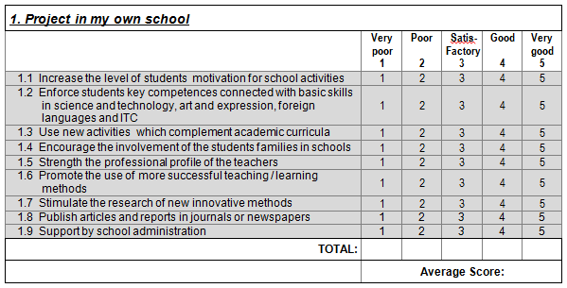
Figure 1
A simple statistical analysis of the average results obtained from every school, provided the intercorrelations among the answers to the nine questions of the first category Project in my own school.

The results obtained from a preliminary analysis of the answers to the nine questions 1.1 to 1.9, collected in every school, can be compared in the histogram presented in Graph 1. The total average of this category and the result was 4.4.
Points
Questions
Graph 1 – Project in my own school
Comparisons between the results of the nine question group shows that the strong points of the project in each school, are the items: 1.2 Enforce students key competences connected with basic skills in science and technology, art and expression, foreign languages and ITC, 1.2 Increase the level of students motivation for school activities 1.3 Use new activities which complement academic curricula, 1.4 - Encourage the involvement of the students families in schools and 1.7 – Promote the use of more successful teaching / learning methods, all of them with a rate superior to 4 (Good).

Graph 2 - Project in my own school radar chart format
The question with lower rates was the 1.9 Support by school administration, with a rate of 3.8 who demonstrate an evident a weak point in this category. Nevertheless the complete results reveal that the rate differences between the questions with the lowest and highest rates were insignificant, which is a strong evidence of a good performance in those areas from all the school partners.
In Graph 2 above, the radar chart format permitted comparing the average of the results obtained in all schools for each question. This Graph is quite revealing, because it contrasts with Graph 1, showing that the majority of rates are between 4.2 and 4.5, with a small difference among the extreme scores, where the maximum was 4,8 (Very good) and the minimum was 3,8 (Good).
These differences are not statistically significant, because the average of this category was 4.4, considered Good, meaning that the project had a good impact on every school.
The most significant observation to emerge from the data comparison of Graph 1 and 2 is the clear and similar results in all answers, which confirms that there were no major differences between the scores obtained in these answers.

Second category: “2. Final products”

This category has 5 questions numbered from 2.1 to 2.5, below in figure 2, graded on the above discrete scale, from 1- Very poor to 5- Very Good. This set of analyses examines the quality of the final products.
The second group of the survey questions concerns to the final products, referring: their quality and sustainability, the extent to which they were disseminated, and also to the way in which they were correlated with the objectives of the project.
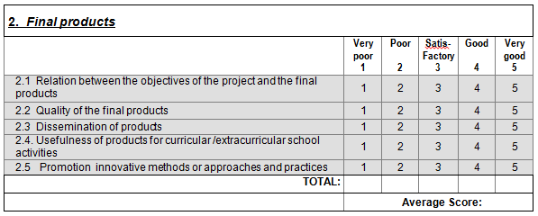
Figure 2

Points
Questions
Graph 2 – Final products
Comparisons between the results of this question group, reveal that strong points of the project in each school are the items: 2.1 Relation between the objectives of the project and final products 4.2 Quality of the final products and 2.4 Usefulness of products for curricular /extracurricular school activities, all of them with a rate superior to 4.5 (Very good).
The questions with lower rates were: 2.3 Dissemination of products in your country and 2.5 Promotion innovative methods or approaches and practices all of them with a rate superior to 4.2 (Good).
In this group, all the questions have obtain rates, expressed by analogous punctuation, from 4,2 to 5. Reviling the standard deviation for this group of questions 0.8, the total average is 4.6, considered high.
In particular its significant to identify the question with less punctuation, the question 2.3 Dissemination of products in your country, with 4.2 points (Good), is the one who demonstrates an apparent a weak point in this category
However considering the results obtained in this group, the differences are very small and aren’t statistically significant; revealing that the final products in each school were considered a highlight of this project.

Third category: “3. Transnational project meetings and learning activities”

The third group of questions, evaluates the relevance of the mobility’s that were effected along the project, the extent to which the pre-established aims were achieved, the involvement of the participants and the impact of the project’s mobility had upon them, as well as various managerial/organisational aspects of the activities performed.
During this first year of project we have done 4 mobility’s: the first in November to Iceland, the second in February to Finland, the third in March to Latvia and the fourth in May to Spain. The motilities to Iceland and to Latvia were transnational project meetings, involving only teachers, the motilities to Finland and to Latvia were learning activities, involving teachers and students.

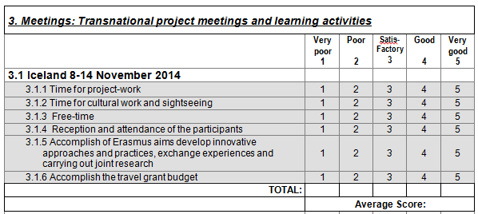
Figure 3
In this category, we include 6 similar questions, in order to evaluate the 4 mobility’s done, independently the type of mobility or the participants.

Transnational project meeting accomplished in Iceland
The first mobility evaluated was the transnational project meeting realised in Iceland on November of 2014
Points
Questions
Graph 3 – Transnational project meeting realised in Iceland
Within the six questions of this category, the respondents unanimously appreciate, with a high assessment score, 3.11 Time for project-work, 3.1.2 Time for cultural work and sightseeing, 3.1.3 Free-time and 3.1.4 Reception and attendance of the participants with scores higher than 4.7, near the maximum ones. The question with less punctuation was 3.1.6 Accomplish the travel grant budget, with 3.2 points (Satisfactory), who demonstrate an effective weak point in this category.
The standard deviation for this group of questions is 1.7, and the total average, 4.7, is very high.

Learning activity accomplished in Finland
The second mobility evaluated was the learning activity accomplish in Finland on February of 2015.
Points
Questions
Graph 4 – Learning activity realised in Finland
All the questions have rates higher or equal than 4.5, the question with lower rate was: 3.2.3 Free-time evaluated with rate of 4.5. The standard deviation for this group of questions is 0.5, and the total average, 4.9, is very high.

Learning activity accomplished in Latvia
The third mobility evaluated was the learning activity accomplish in Latvia on March of 2015.
Points
Questions
Graph 5 – Learning activity realised in Latvia
Most the questions have rates equal to the maximum score 5, with the lowest score being given to question 3.3.3 Free-time who has a lower rate of 4, who demonstrate an operational weak point. The standard deviation for this group of questions is 1, and the total average, 4.8, is very high.

Transnational project meeting accomplished in Spain
The fourth mobility evaluated was the transnational project meeting realise in Spain on May of 2014
Points
Questions
Graph 6 – Transnational project meeting realised in Spain
All the questions have rates higher than 4 (good), the questions who get lower rates was: 3.4.1 Time for project-work, 3.4.3 Free-time and 3.4.5 Accomplish of Erasmus aims develop innovative approaches and practices, exchange experiences and carrying out joint research.
The standard deviation for this group of questions is 0.6, and the total average, 4.7, is very high.

Fourth category: “4. Coordination process”
The six questions belonging to this category refer to the coordination and managerial process/activity of the project, focusing to coordinator – partner’s communication, the personal contribution and involvement of the European project coordinator.
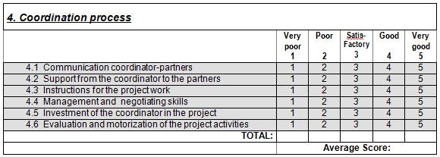
Figure 4

Graph 7 – Coordination process
The questions with higher rates were: 4.1 Communication coordinator-partners 4.2 Support from the coordinator to the partners, 4.5 Investment of the coordinator in the project and 4.6 Evaluation and motorization of the project activities, the questions who get lower rates were: 4.3 Instructions for the project work and 4.4 Management and negotiating skills.
All the questions have rates higher than 4.5 (Very good). The standard deviation for this group of questions is minimal (0.4), and the total average is 4.7.

Conclusions

Comparing the average results obtained from the 4 categories, we see that the averages are between 4.4 (1. Project in my own school) and 4.8 (3. Transnational project meetings and learning activities). The detailed analyses of these results show that the strongest points of the project were the quality of the transnational project meetings and learning activities, revealing the high quality of the mobility’s, were the project strategy and final products are planned, discuss and presented.
The lowest point was the quality of the project in each school; this category had an average of 4.4, even if the classification was good, we consider important examine and discuss in order to improve. The most significant observations to emerge from this result are the lower support of the school’s administration in some schools, and the use of new activities which complement academic curriculum.
The most important remark that becomes visible from the judgement of the data in Graph 2 - Final products, is the lower rates obtained from the question dissemination of final products, who reveals some fragilities.
The general analysis of this result demonstrate that the differences between the questions with the lowest and highest rates was not significant, because all of them are superior of 4.4 (good) which is a strong evidence of a very good performance and quality in those areas from all the school partners.

