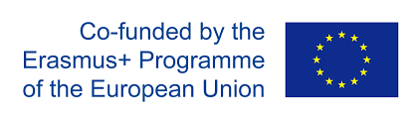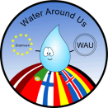

Auto-Evaluation Report
Third year of Erasmus Plus Project
“Water Around Us”

Isabel Castro
(Agrupamento de Escolas de Valongo - Portugal)
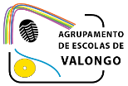

June 2017

Contents
Introduction 3
Results Presentation 4
1. First category: “Project in my own school” 4
1.1 Comparing rate evolution “Project in my own school” during 3 years of project 6
2. Second category: “Final products” 7
2.1 Comparing the rate evolution “Final products” during 3 years of project 8
3. Third category: “Transnational project meetings and learning activities” 9
3.1 Transnational project meeting accomplished in Latvia 10
3.2 Learning activity accomplished in Germany 11
3.3 Learning activity accomplished in Iceland 12
3.4 Transnational project meeting accomplished in Portugal 13
4. Fourth category: “Coordination process” 14
Conclusions 15

Introduction

Related with the Erasmus plus project 2014-2017 “Water around us”, financed by the EU, Key action 2, we produced a questionnaire for teachers, to collect information from all of the 7 partner schools, in order to measure the quality of the first year of collaborative work.
For the conception of the questionnaire we have considered the major objectives of the partnership, and produced 44 close and scaled questions. All the questions are very simple, objective, and use the same response format, graded on a continuum scale from 1 to 5, with the significance 1- Very poor, 2- Poor, 3- Satisfactory, 4- Good and 5-Very Good.
In order to check the questionnaire we pre-tested it, through a small sample of respondents, who we interviewed and got their impressions to confirm that the questions correctly reproduced their opinions.
The questions were grouped into coherent sections and divided into four central categories so that it could be evaluated: “1. Project in my own school” (9 questions), the “2. Final products” (5 questions), 3. Transnational project meetings and learning activities (24 questions), and 4. Coordination process (6 questions).
The questionnaire was fulfilled by each partner school and with the results we elaborate this evaluation report.

Results Presentation

We collected 7 questionnaires, one from each school partner; all of them fulfilled all categories, except from the Portuguese school “Agrupamento de Escolas de Valongo”, who didn’t accomplish the category “Coordination process”, since it is the school that coordinated the project and responsible for this evaluation report.
With the collected information, we have done the treatment of the entire data, and presented a standard approach with comments or discussions, supported by figures and graphs.

“Project in my own school”

The first set of analyses examines the impact of the project in each school. This category has 9 numbered questions (figure 1), graded on the above discrete scale, from 1- Very poor to 5-Very Good.
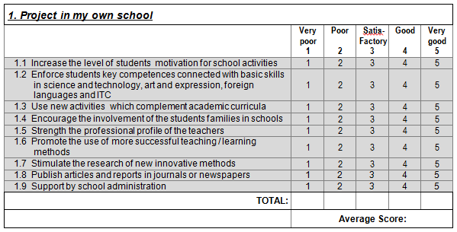
Figure 1

A simple statistical analysis of the average results obtained from every school, provided the intercorrelations among the answers to the nine questions of the first category Project in my own school.
The results obtained from a preliminary analysis of the answers to the nine questions 1.1 to 1.9, collected in every school, can be compared in the histogram presented in Graph 1. The total average of this category and the result was 4.7.Points
Points
Questions
Graph 1 – Project in my own school
Comparisons between the results of the nine-question group shows that the strong points of the project in each school, are the items: 1.1 Increase the level of students motivation for school activities 1.2 Enforce students key competences connected with basic skills in science and technology, art and expression, foreign languages and ITC and 1.4 - Encourage the involvement of the students families in schools, all of them with a rate superior to 4.4 (Good).

Graph 2 - Project in my own school radar chart format
The questions with lower rates was the 1.6 Promote the use of more successful teaching / learning method with a rate of 4,4 and 1.9 Support by school administration, with a rate of 4,4 who demonstrate two evident weak points in this category.
In Graph 2 above, the radar chart format permitted comparing the average of the results obtained in all schools for each question. This Graph is quite revealing, because it contrasts with Graph 1, showing that the majority of rates are between 4.4 and 4.9, with a small difference among the extreme scores, where the maximum was 4,9 (Very good) and the minimum was 4,4 (Good).
These differences are not statistically significant, because the average of this category was 4.6, considered Very Good, meaning that the project had a good impact on every school.

1.1 Comparing rate evolution “Project in my own school” during 3 years of project

Comparisons between the results of the category Project in my own school during the 3 years of project, are evident the improvement and evolution of the project.

Graphs 1.1 and 1.2 – Results obtained in first year (2013-14) and second year (2015-16)
In particular, we analysed the question with lower rates in the project’s first (2013-14) and second year (2015-16), question 1.9 Support by school administration, with the same rate of 3.8 in the first and second year of project, who demonstrated an evident a weak point in this category.
In the third year it got a punctuation of 4,4,. indicating a significant evolution of this item.

“Final products”

This category has 5 questions numbered from 2.1 to 2.5, below in figure 2, graded on the above discrete scale, from 1- Very poor to 5- Very Good. This set of analyses examines the quality of the final products.
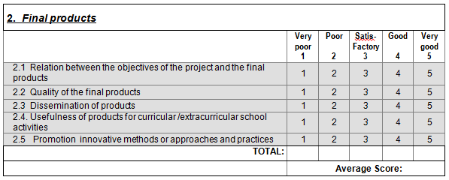
Figure 2

The second group of the survey questions concerns to the final products, referring: their quality and sustainability, the extent to which they were disseminated, and also to the way in which they were correlated with the objectives of the project.
Points
Questions
Graph 2 – Final products
Comparisons between the results of this question group, reveal that strong points of the project in each school are the items: 2.1 Relation between the objectives of the project and final products, 2.2 Quality of the final products and 2.3 Dissemination of products, all of them with a rate superior to 4.5 (Very good).
The questions with lower rates were: 2.4 Usefulness of products for curricular /extracurricular school activities and 2.5 Promotion innovative methods or approaches and practices all of them with a rate superior to 4.2 (Good).
In this group, all the questions have obtained rates, expressed by analogous punctuation, from 4,2 to 4,8. Reviling the standard deviation for this group of questions 0.8, the total average is 4.6, considered high. Considering the results obtained in this group, the differences are very small and aren’t statistically significant; revealing that the final products in each school were considered a highlight of this project.

2.1 Comparing the rate evolution “Final products” during 3 years of project

Comparisons between the results of the category Final products during the 3 years of project, made it evident that most of the items in it’s third year, had decreasing of the punctuation.

Graphs 2.1 and 2.2 – Results obtained in first year (2013-14) and second year (2015-16)
In particular, its noteworthy to identify the question with less punctuation in the years 2013-14 and 2015-16, the question 2.3 Dissemination of products in your country, respectively with 4.2 and 4.3 points (Good), is the one who demonstrated an apparent a weak point in this category. Comparing this rates with the result obtained in 2016-17, 4.7 points, it’s evident a significant evolution of this item.

“Transnational project meetings and learning activities”

The third group of questions, evaluates the relevance of the mobility’s that were effected along the project, the extent to which the pre-established aims were achieved, the involvement of the participants and the impact of the project’s mobility had upon them, as well as various managerial/organisational aspects of the activities performed.
During this first year of project we have done 4 mobility’s: the first in September to Latvia, the second in December to Germany, the third in March to Iceland and the fourth in May to Portugal. The motilities to Latvia and to Portugal were transnational project meetings, involving only teachers, the motilities to Germany and to Iceland were learning activities, involving teachers and students. In this category, we include 6 similar questions, in order to evaluate the 4-mobility’s done, independently the type of mobility or the participants
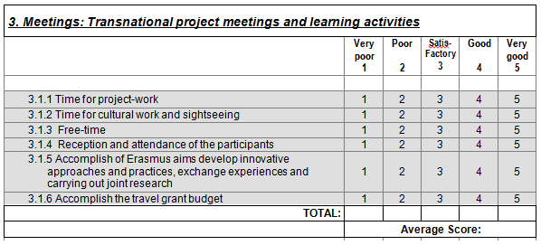
Figure 3
.

3.1 Transnational project meeting accomplished in Latvia

The first mobility evaluated was the transnational project meeting realised in Latvia on September of 2016.
Points
Questions
Graph 3 – Transnational project meeting realised in Latvia
Within the six questions of this category, the respondents unanimously appreciated, with a high assessment score, the items: 3.1.1 Time for project-work, 3.1.2 Time for cultural work and sightseeing, and 3.1.4 Reception and attendance of the participants all with the maximum score of 5,0. The question with less punctuation was 3.1.3 Free-time, with score of 4.0 (Good).
The standard deviation for this group of questions is 1, and the total average, 4.7, is considered very high.

Learning activity accomplished in Germany

The second mobility evaluated was the learning activity accomplish in Germany on December of 2016.
Points
Questions
Graph 4 – Learning activity realised in Germany

The questions 3.2.1 Time for project-work, 3.2.2 Time for cultural work and sightseeing and 3.2.4 Reception and attendance of the participants have rates equal to the maximum score of 5 the question with lower rate was: 3.2.3 Free-time evaluated with rate of 4. The standard deviation for this group of questions is 1, and the total average, 4.7, is very high.

Learning activity accomplished in Iceland

The third mobility evaluated was the learning activity accomplish in Iceland on March of 2017.

Points
Questions
Graph 5 – Learning activity realised in Iceland

The questions 3.3.2 Time for cultural work and sightseeing and 3.3.4 Reception and attendance of the participants obtained the maximum score of 5. The question who got the lowest rates was 3.3.6 Accomplish the travel grant budget. The standard deviation for this group of questions is 0,7, and the total average, 4.7, is very high.

Transnational project meeting accomplished in Portugal

The fourth mobility evaluated was the transnational project meeting realised in Portugal on May of 2017
Points
Questions
Graph 6 – Transnational project meeting realised in Portugal

The questions who got the highest rates were: 3.4.2 Time for cultural work and sightseeing and 3.4.4 Reception and attendance of the participants both with the maximum score of 5. The lowest score being given to question 3.4.3 Free-time who has the rate of 4,1.
All the questions have rates higher than 4 (good). The standard deviation for this group of questions is 0.9, and the total average, 4.7, is very high.

“Coordination process”

The six questions belonging to this category refer to the coordination and managerial process/activity of the project, focusing coordinator – partner’s communication, the personal contribution and involvement of the European project coordinator.
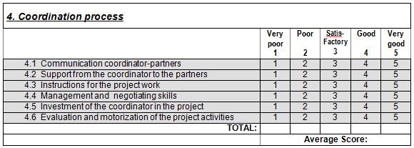
Figure 4

Graph 7 – Coordination process
The questions with higher rates, with the score of 5 were: 4.1 Communication coordinator-partners 4.2 Support from the coordinator to the partners, 4.5 Investment of the coordinator in the project and 4.6 Evaluation and motorization of the project activities, the questions who get lower rates were: 4.3 Instructions for the project work and 4.4 Management and negotiating skills.
All the questions have rates higher than 4.5 (Very good). The highest deviation for this group of questions is minimal (0.5), and the total average is 4.8.

Conclusions

Comparing the average results obtained from the 4 categories, we see that the averages are between 4.6 (1. Project in my own school) and 4.7 (3. Transnational project meetings and learning activities). The detailed analyses of these results show that the strongest points of the project were the quality of the transnational project meetings and learning activities. This revealing the mobilities importance, for the project implementation, specifically for planning, monitoring and evaluating the project.
The lowest point was the quality of the project in each school; this category had an average of 4.6, even if the classification were good, we consider important examining and discussing in order to improve. The most significant observations to emerge from this result are the lower support of the school’s administration in some schools, and the use of new activities which complement academic curriculum. Nerveless during the 3 years of partnership we could verify a positive evolution.
The most important remark that becomes visible from the judgement of the data in Graph 2 - Final products, is that the lower rates obtained from the question dissemination of final products, in the first 2 years of partnership who revealed some fragilities, have had in the third year, very positive evolution, revealing the efforts of the partnership in correcting this week point.
The general analysis of this result demonstrates that the differences between the questions with the lowest and highest rates was not significant, because all of them are superior to 4.4 (good) which is a strong evidence of a very good performance and quality in those areas from all the partners.
Those 3 years of project were a strong trail of cooperation, creativity, innovation and partnership of knowledge and experience from an enthusiastic group of 7 schools from 6 countries.
A word of appreciation to all of those who took part in, the teachers, students, partners and everyone involved, in special the coordinators, for their contribution to the success of the project.

