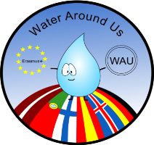
Comparative analyse of WATER in subjects related with the curriculum in:
Iceland Latvia Finland Portugal Spain Germany

Country | Level | Subject | General topics
Iceland  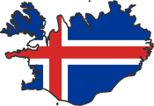 | 4th grade | Biology | - The importance of water in every day live.  - The water cycle. The melting of ice and glaciers.
 | 5th grade | Geography | - Know the nearest rivers, lakes, streams and oceans around and in Iceland
 |  | Chemistry and physics | - The importance of water for plants and animal life
 |  | Biology | Water in nature  - State of water in everyday life  - Drinking water purity importance
 | 6th grade | Geography | - Knowing the nearest rivers, lakes, streams and oceans around and in the Scandinavian countries
 |  | Chemistry and physics | - The water H20  - The main water pollution sources  - Water quality by bio indicators  - Water cycle in nature
 |  | Biology | - Water in the human body.  - The proportion of water in the human body.
 | 7th grade | Geography | - Knowing the nearest rivers, lakes, streams and oceans in Europe
 |  | Chemistry and physics | - The ocean current and the importance of climate formation  - Water molecule
 |  | Biology | - Live organism in water.  - Water in the human body .  - The proportion of water in the human body.
 | 8th grade | Geography | - The importance of water as the most important natural resource in the world and the basic for development of life on earth.  - The proportion of water on the surface of the planet.  - The location of the main oceans, freshwater lakes and rivers on the world map.  - The importance and function of the rain forests.  - The climate and water in atmosphere.  - The role access water has on urban development and position of civilization.  - The role water has as a way of transport and communication. (Oceans, rivers and canals).  - Hydric resources and water energy.  - Development aid in connection with water resources and use of hydric energy.  - Rivers and waterfalls in landscape.  - Ocean currents and the importance of the Gulf stream to human habitation in the northern part of the world.  - The importance of fisheries and connected industries.  - Coastline culture.  - Water pollution.  - The ice of the North- and South-poles as freshwater resources.  - Management of the ocean resources.  - Navigation routes and possible changes due to melting of the polar ice.  - The effect dams and other hydrographical complexes have on the landscape and culture.
 |  | Chemistry and physics | - Water in the chemical reactions.  - Characteristic of water molecules.  - Distillation of water.  - Different form of water.  - Acid rain.
 |  | Biology | - Water in live organism.  - Water in the human body.  - The proportion of water in the human body.
 |  | Art | - Water as an endless inspiration in poetry, literature and visual arts.  - Physical use of water in creating visual art.
 | 9th grade | Biology | - The climate: water in atmosphere, rain and steam  - The sea  - The importance of water in the climate
 |  | Geography | - The role water has as a way of transport and communication. (Oceans, rivers and canals).  - Water energy.  - Rivers and waterfalls in landscape.  - Ocean currents and the importance of the Gulf stream to human habitation in the northern part of the world.  - Coastline culture.  - Water pollution.  - The ice of the North- and South-poles
 |  | Chemistry and physics | - water molecule structure-chemical bonds  - electrolytic and water  - pH
 | 10th grade | Astronomy | - Water on earth and in space  - Moon and tides  - Winter and summer
 |  | Physics | - Temperature in water  - Heating and cooling e.g. Icelanders heat up their houses with warm water  - Electricity made from waterfalls and hot steam  - Lightning’s  - Sound through water l  - Light and water, reflection and more  - Nuclear energy and water cooling  - Energy in water  - Water pressure  - Density in materials/water  - Hydraulic equipment  - Movement and water
Portugal  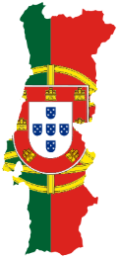 | 1th grade | Experiments with water | - Capacity/volume, regardless of shape of the object  - Identify some physical properties of water  - Recognize materials floating and not floating  - Investigate the effect of water substances
 | 5th grade | Natural sciences | - The importance of the water for living bodies  - Understand the importance of water to living things  - Understand the importance of water quality for human activity  - Water and the influence of abiotic factors on morphological and behavioural adaptations of animals
 | 6th grade | Natural sciences | - Water related to social problems, pollution, water/soil,  - Water and healthy enviroments
 | 7th grade | Geography | - The rivers in the landscape  - The hydrography as a landscape unites  - The water in atmosphere  - The climate water in atmosphere, rain and steam  - The marine current and sea erosion  - The importance of water in the climate  - Water in the atmosphere: Liquid, solid and steam  - The precipitation  - Hydrographical complex  - Rivers as water supplies
 |  | Physical and  Chemistry | - Planet earth have unique characteristics related with water in liquid form
 | 8th grade | Geography | - Hydric resources  - Water energy
 |  | Physical and Chemistry | - Importance of water in the chemical reactions
 |  | Natural sciences | - The earth subsystem Hydrosphere  - The importance of water as abiotic factor for animal and plants  - Natural catastrophe Foods  - Water pollution  - Hydric resources  - Water supplies, potable water in the planet
 | 9th grade | Geography | - Acid rain, the decrease of ozone layer
 |  | Natural sciences | - Water in the human body  - Water energy
 | 10th grade | Geography | - Water resources  - Underground water supplies (aquifers) Rivers, basins and lakes  - Thermal water and spring water  - Management of water resources and water protection  - Problems connected with fresh water resources  - Management of the ocean and maritime resources  - Ocean water
 |  | Physic and Chemistry | - Characteristics of water molecule  - Proprieties of water
 |  | Biology and Geology | - Water in live organism  - Importance of some proprieties of water for organisms  - Acid rain, the decrease of ozone layer
 | 11th grade | Geography | - Water (Rivers and oceans) as systems of communications and transport
 |  | Physic and Chemistry | - Water resources
 |  | Biology and Geology | - The problems connected with: the anthropic occasions close rivers and oceans  - Water supplies: rivers and underground water (aquifers)
 | 12th grade | Geography | - The water wars  - Ambiental problems: decreasing of fresh water
 |  | Geology | - Underground water supplies: Aquifers
Latvia  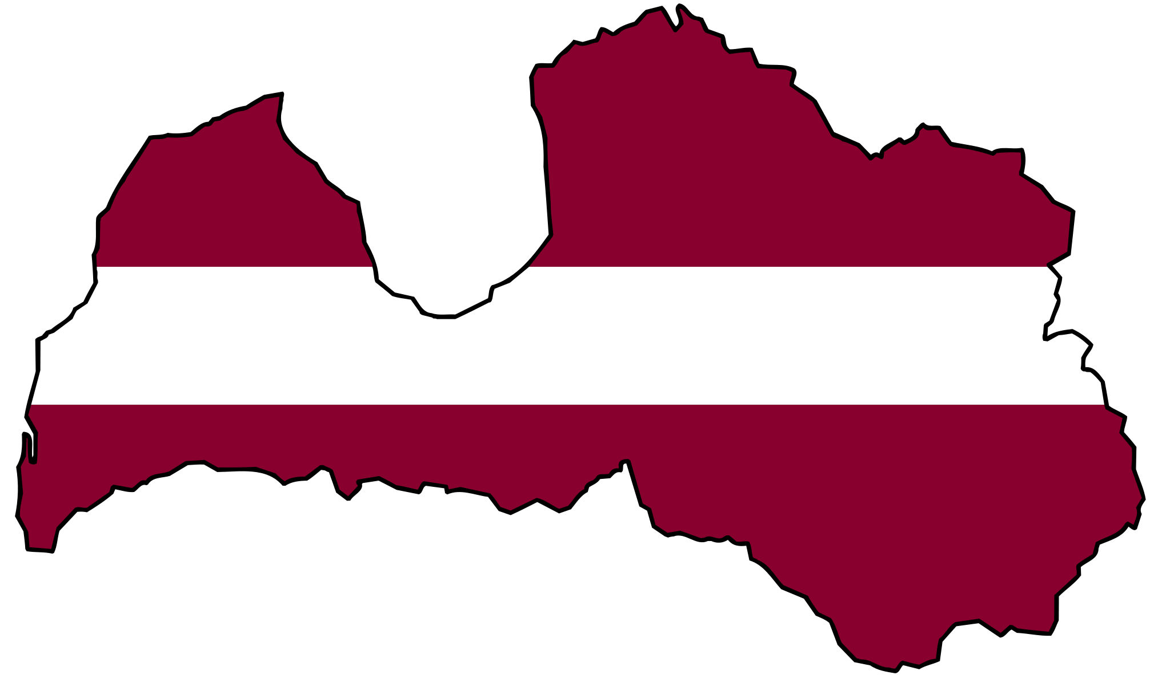 | 5-6th grade | Science | - The importance of water to plant and animal life  - Knowing the nearest rivers, lakes, streams  - The types and precipitation Water in nature  - State of eater in everyday life  - Drinking water purity importance  - The main water pollution sources  - Water quality by bioindicators  - Water cycle in nature  - Mountain streams an plain rivers  - Formation of the waterfall and rapids  - Freshwater and saltwater  - Solutions in everyday live
 | 7-9th grade | Biology | - Assess air or water of-pollution through bioindicators  - Water role to human environmental impact of neighbourhood ecosystem an human organisms
 |  | Geography | Earth´s hydrosphere  - Hydrosphere components, the World Ocean, ocean floor, shelf, edges Sea, inland sea, the new line in the mountains  - The importance of water resources in the natural course of the process and the lives of people in different regions of the world.  - The ocean current and the importance of climate formation  - Ice, glaciers and avalanche formation  - Continental glaciers and their importance of the earth´s fresh water resources structure  - The sources of pollution of the world´s oceans  - Baltic Sea and in the Gulf  Groundwater, sources  - Latvian rivers, river basins  - Types of water pollution causes and effects lakes and regional location c
 | 8-9th grade | Chemistry | - Water decomposition  - The pH in different water  - Acid rain formation and impact to environment  Water in human life:  - Distilled water  - Physical properties of pure water  - Water reactions with metal oxides and non-metallic elements oxides  - Solubility of substances in water  - Modern drinking water treatment plants  - Drinking water preparation and wastewater purification  - The water pollution, water pollutants  - The effects of water pollutants to environment, human health
 | 10-12th grade | Chemistry | - Disperse systems  - water as solvent  - water molecule structure-chemical bonds  - crystal hydrates  - electrolytic dissociation  - pH  - Water solution electrolysis  - Metal reacting with water  - Water role to chemical and electrochemical corrosion processes  - The water hardness  - Analyse water quality  - Hydrocarbon and other organic compound hydration.
Finland  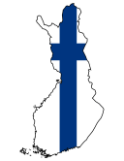 | 7th grade | Biology | - Lake ecosystem (features of water, water cycle, flora an fauna and lakes)  - Factors threatening waterways as hypertrophication
 |  | Geography | - Oceans  - Rivers and lakes in the American Continent
 |  | Chemistry | - Water is essential for life/water for life  - The most important properties of water
 |  | Physics | - Properties of water
 | 8th grade | Geography | - Water cycle on earth  - Saltiness of seas  - Pollution of waterways (seas, lakes, rivers)  - Fresh water resources and lack of clean and fresh water  - Marine areas surrounding Europe  - Erosion caused by water and ice  - Largest rivers and lakes in Europe
 |  | Chemistry | - Water molecule  - Acid rain  - Water and sewage treatment
 |  | Chemistry optional course | - Water analyses
 |  | Physics | - Density of water, buoyancy
 | 9th grade | Geography | - Special characteristics of Finnish waterways (lakes and rivers)  - Finnish rivers and lakes  - The Baltic sea; ice age theme water overlaps theme wind when studding e.g. the formation of cyclones
 |  | Physics | - Water power plants
Spain  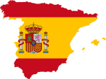 | 1th grade | Environmental | - Responsible use of water
 | 2th grade | Environmental | - Analysis of the aquatic ecosystem
 | 3th grade | Environmental | - Characteristics of rivers  - Water cycle.
 | 4th grade | Environmental | - Metrological variables: Humidity and precipitations.  - States of water.  - Changes of states of water.
 | 5th grade | Environmental | - Metrological variables: Humidity  - Fluvial and glacial erosion.  - Pollution and waste of water
 |  | Math | - Relation between weight and capacity of water
 |  | Citizenship | - Valuation of the public service: supply of drinking water
 | 6th grade | Environmental | - Density.  - States of water. Changes of states.  - Solubility in water  - Chemistry characteristics of water
 | 7th grade | Biology | - Hydrosphere.  - Beginning and distribution of water on earth.  - Water in oceans, water in continents.  - Water cycle, water characteristics, states of water.  - Uses of water.  - Water pollution, waste water treatment, water saving.  - Meteorological variables: clouds and precipitations.  - Water is essential for life on earth.  - Water, molecular component of living matter  - Biological importance of water.  - Fluvial and glacial erosion.  - Density, volume.  - Solution, concentration.  - States of water, changes of states.  - Formula of the molecule of water.
 |  | Geography | - Water essential for life on earth.  - Hydrosphere.  - Coastal and submarine reliefs.  - Fluvial erosion.  - Continental water (river, lake, glacier and underground water) and marine water.  - The most important rivers, lakes and seas on earth.  - Water, an earth heritage.  - Parts of a river.  - Precipitation. Rivers and the landscape  - Weather, water and coast in human life.  - Over exploitation of water  - Most important rivers, seas, oceans, islands and peninsulas of Spain.
 |  | History | - Nile river and the ancient Egypt.  - River civilizations (Mesopotamia)
 | 8th grade | Biology | - Plants to purify water.  - Submarine relief.  - Tsunami.
 | 9th grade | Biology | - Management, pollution and treatment of water.  - Acid rain  - Coastal relief.  - Geological action of the continental water.  - Underground water  - Rapids  - Torrent  - Rivers  - Fluvial terraces.  - Infiltration.  - Aquifer.  - Glacier.  - Sea.
 |  | Geography | - Ocean, river, lake and underground water.  - Water and human occupation  - Precipitations  - Climograph.  - Europe's coasts.  - The most important rivers and lakes in Europe.  - Aquaculture.
 |  | Chemistry | - Solubility in water.  - Solutions.  - Water molecule
 |  | Phycology | - Density of water.  - Changes of states of water.
 |  | Technology | - Water pollution because of the production of electric energy
 | 10th grade | Biology | - Water (terrestrial modelling agents)  - Water (environmental factor in the terrestrial environment)
 |  | Physics | - Communicating vessels.  - Hydraulic systems  - Archimedes' Principle.
 |  | Technology | - Water installation in a house.  - Hydraulic installation.
Germany  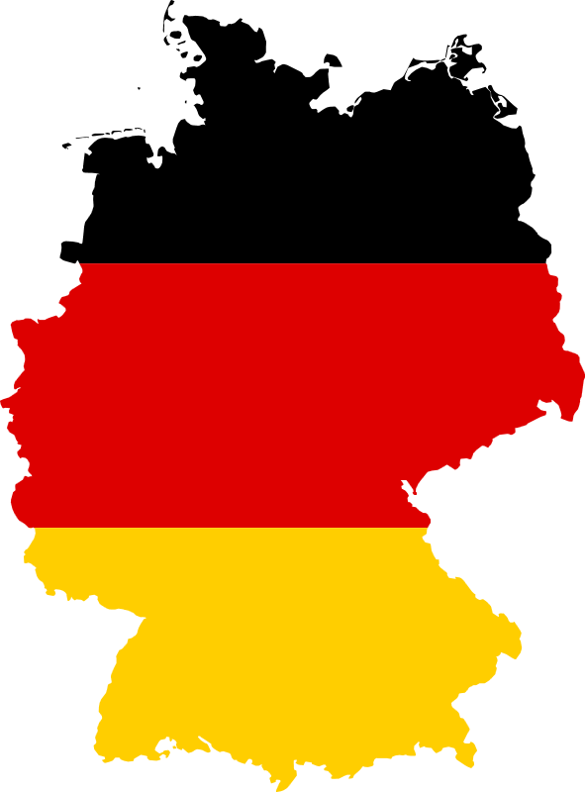 | 5th grade | German | - Being creative with language rhymes and riddles about water  - Factual and functional text about water  - Literary texts(nature-water-related poems)  - Young readers literature(water-related)  - Various water-related texts
 |  | GSE=  Geography  History and social studies | - Evolution, Genesis, and earth  - Orientation on maps(oceans)  - Environnemental protection (Rainwater utilisation etc.)  - The Nile-lifeline of Egypt
 |  | PCB=  Physical, biology and Chemistry | - Nature in the course of the year  - Properties of chem. Substances(solubility, boiling- and melting temperature)
 | 6th grade | German | - Being creative with language rhymes and riddles about water  - Factual and functional text about water  - Literary texts(nature-water-related poems)
 |  | GSE=  Geography  History and social studies | - Roman Empire(aqueducts, fountains, spas)  - Bavaria (rivers, lakes, channels)
 |  | PCB=  Physical, biology and Chemistry | - Basic of life: water  - Properties of water  - Quality of water  - Habitat: water  - Organisms who live near/in water  - Adapting of organisms to the habitat water
 |  | Religion  (C and P) | - Symbols and sacraments(original symbol of mankind : baptism, water, etc.)
 | 8th grade | German
 |  | GSE=  Geography  History and social studies | - Europe tourism, oceans, lakes, rivers i.e. river cruises on the Main River  - Europe Single Market: getting to know rivers, seas and oceans as important traffic routes
 |  | PCB=  Physical, biology and Chemistry | - Quality of soil: water-holding capacity, pH-level, compaction of soil  - Function of forests: water reservoir, recreation area (lakes, rivers, moors, etc.)  - material properties in daily life and technology  - environmental protection environmental hazards of water (chemical substances, fertilizers, acid rain, road salt)
 |  | Religion  (C and P) | - Water of life (catholic and protestant) symbols, rituals, baptism.
 |  | Politic | - Water mafia, who owns water rights?

