Maurice Wilkins

Maurice Hugh Frederick Wilkins was born on December 15th, 1916, in the rural township of Pongaroa, New Zealand. He died in the 5th October of 2004.
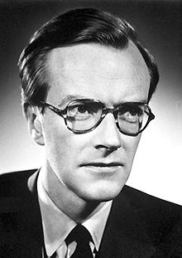
His father was Edgar Wilkins, a doctor of medicine from Dublin, Ireland. His mother was Eveline Whittaker, the daughter of a senior Dublin policeman. Both of Maurice’s parents were committed vegetarians.
His parents sailed halfway around the world from Ireland to New Zealand three years before Maurice’s birth seeking a healthy environment to raise their planned family. Their daughter Eithne was born in 1914, followed by Maurice in 1916.
Maurice spent his early years living in New Zealand’s capital city, Wellington. In later years he recalled how precious that time had been to him, describing the blue skies, the sea views, and wholesome vegetarian food.
At the age of 6, Wilkins was brought to England and educated at King Edward’s School, Birmingham. He studied physics at St. John’s College, Cambridge, taking his degree in 1938. He then went to Birmingham University, where he became research assistant to Dr. J. T. Randall in the Physics Department. They studied the luminescence of solids.
https://www.famousscientists.org/maurice-wilkins/
Wilkins' work on DNA falls into two distinct phases. The first was in 1948–50, when his initial studies produced the first clear X-ray images of DNA, which he presented at a conference in Naples in 1951 attended by James Watson. During the second phase, 1951–52, Wilkins produced clear "B form" "X" shaped images from squid sperm, images he sent to James Watson and Francis Crick.
Then Watson and Crick discovered the structure of the DNA, thanks by some X-ray photos took by Wilkins.
https://en.wikipedia.org/wiki/Maurice_Wilkins#DNA_%E2%80%93_Phase_One
The link of the game is:

https://learningapps.org/display?v=pyje1sp3a2

