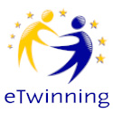
eTWINNING PROJECT – 2019-20– JEKYLL AND HYDE Student self-evaluation
 | PAGE | task | Tools used | Date  (month) | I have done it and I am very happy with the result  5 | I have done it and I think it is ok  4 | I have done it but I am not very happy with the result  3 | I am still working on it  1 | I haven’t started yet!!!!!  0
1 | getting to know each other: | this is me:  - Description  - Photo collage
 |  | this is my partner
 |  | country…
my partners’ language
…

