EMOTIONS-From Shakespeare to Emojis
TASK 1:
- I can express no kinder sign of love, than this kind kiss. (Henry VI)
A-Here is a kiss to show you how much I love you.
- How much better is it to weep at joy than to joy at weeping. (Much Ado About Nothing)
D-It’s better to cry from laughing than to laugh at someone else crying.
- The silence often of pure innocence persuades when speaking fails. (Winter’s Tale)
E- Sometimes it’s better not to say anything.
- I am burn’d up with inflaming wrath. (King John)
C- I am feeling extremely angry.
- Present fears are less than horrible imaginings. (Macbeth)
B-Don’t worry. There’s nothing to be scared of. It’s all in your imagination
- The very instant I saw you did my heart fly at your service. (The Tempest)
F-As soon as I saw you I fell in love with you

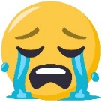
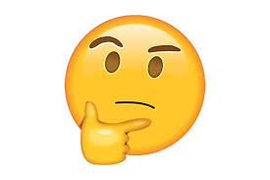
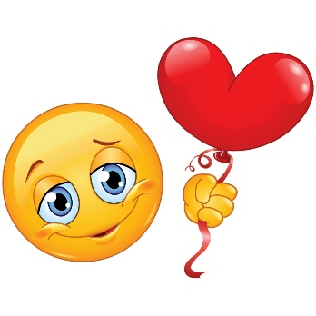
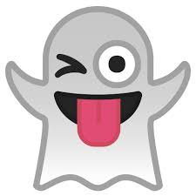
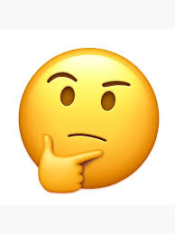
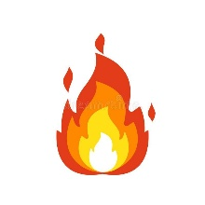
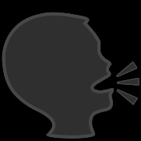
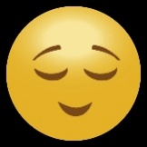
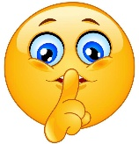
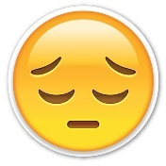

1- The Emojis that are equals are the thing of the heart and the kiss
2-because they help us communicate and express feelings, but they also show features of our personality.
3-
I'm going to invent an Emoji from a pencil
2
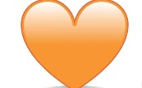
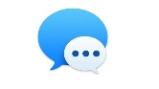
5- un. Para mis. Y mis os he echado de menos.

