FROM SHAKESPEARE TO EMOJIS
TASK 1
- I can express no kinder sign of love, than this kind kiss. (Henry VI)
- How much better is it to weep at joy than to joy at weeping. (Much Ado About Nothing)
- The silence often of pure innocence persuades when speaking fails. (Winter’s Tale)
- I am burn’d up with inflaming wrath. (King John)
- Present fears are less than horrible imaginings. (Macbeth)
- The very instant I saw you did my heart fly at your service. (The Tempest)
A ☐ Here is a kiss to show you how much I love you.
B ☐ Don’t worry. There’s nothing to be scared of. It’s all in your imagination.
C ☐ I am feeling extremely angry.
D ☐ It’s better to cry from laughing than to laugh at someone else crying.
E ☐ Sometimes it’s better not to say anything.
F ☐ As soon as I saw you I fell in love with you.
1 – a 2 – d 3 – e 4 – c 5 – b 6 – f
TASK 2
- I can express no kinder sign of love, than this kind kiss. (Henry VI)
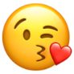
- How much better is it to weep at joy than to joy at weeping. (Much Ado About Nothing)
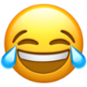
- The silence often of pure innocence persuades when speaking fails. (Winter’s Tale)
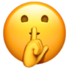
- I am burn’d up with inflaming wrath. (King John)
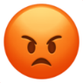
- Present fears are less than horrible imaginings. (Macbeth)
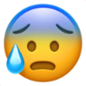
- The very instant I saw you did my heart fly at your service. (The Tempest)
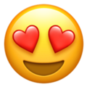

TASK 3
- 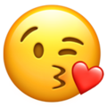
- I believe people use emoji to communicate better their mood while they are messaging: with a message, in fact, it is not always easy to understand what you are feeling.
- Often emoji are not well seen, especially when it comes to messages that are more formal.
- I was when I 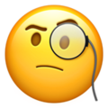 a walking across the searching for a ; luckily I had a in my , so I it away from and it away to catch it.

