Naming Emotion:

Task 1:
Fear ≠ anger
joy ≠ sadness
admiration ≠ disgust
anticipation ≠ surprise
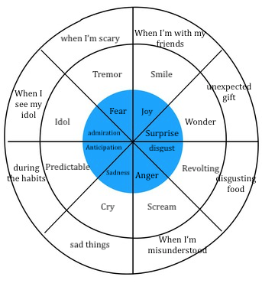
Task 6:
- Joy
- Sadness
- Anger
- Disgust
- Fear

Task 8:
1) The child is angry because someone throws a can in his head.
2) The girl is bored because she has to wait 1 hour.
3) She is excited because she’s having fun on the roller coaster.
4) The boy is happy because he's about to have fun on the roller coaster.
5) He is hangry when he sees all the food.
6) He is sad because he's short.
7) He is scared because he sees a skeleton.
8) She is shy because a clown offered to her a rose.
9) The girl is sleepy because she ran all over the park.
10) She is thirsty becuse she hasn’t drink anything.
11) The man is tired because he ran all over the park too.
12) ) He is worried because her friend has fallen down.

