LINKING EMOTIONS
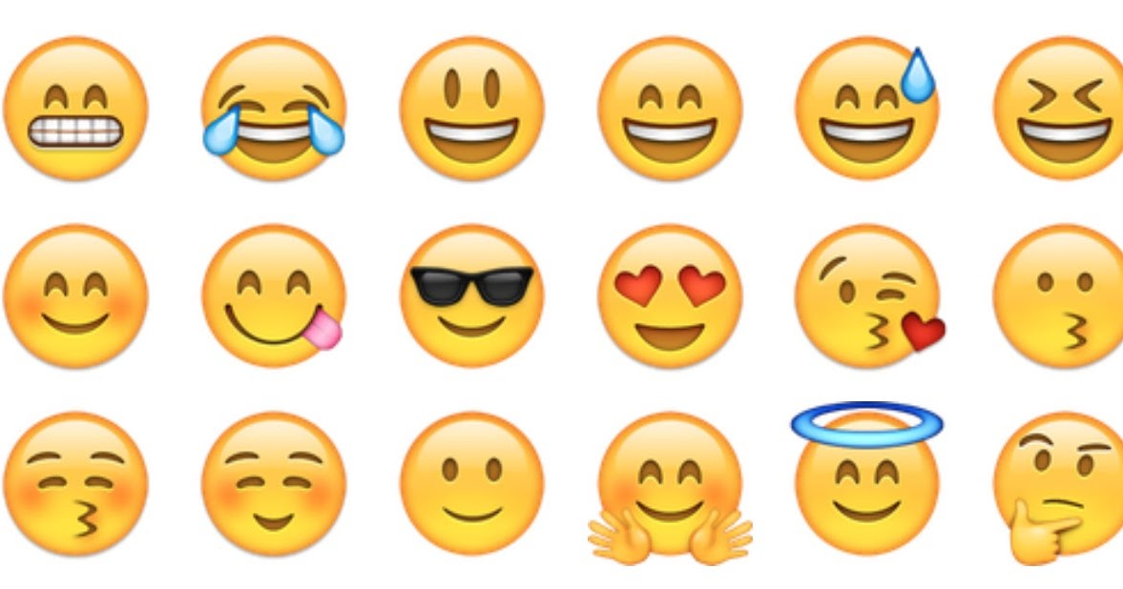
TASK 2
- Sadness – I feel sad
- Excitement – I feel excited
- Relief – I feel relieved
- Shock – I fell shocked
- Embarrassment - I feel embarrassed
- Stress – I fell stressed
- Satisfaction – I fell satisfied
- Euphoria – I feel euphoric
- Serenity – I feel serene
- Hatred – I hate
- Frustration – I fell frustrated
- Confusion – I feel confused
- Boredom – I feel bored
- Surprise – I feel surprised
- Fear – I feel scared
- Happiness – I feel happy
- Tenderness – I ‘m tender
- Kindness – I’m kind
- Melancholy – I miss you
- Concern – I feel worried
- Temptation – I tempt
- Guilt – I feel guilty
- Delight – I delight
- Affection – I have affection for you
- Enthusiasm – I feel enthusiastic
- Solitude – I feel alone
- Anger – I’m angry
- Admiration – I admire you
- Rage – I’m angry
- Apprehension - apprehensive

TASK 3

- When I'm away from someone I feel sad but above all I feel a lot of melancholy .
- When someone tells me that there will be a surprise for me I get angry because I want to know immediately what it is.
- When a loved one is sad, I become very apprehensive and try to help him in every way.

