Task: 1 and 2

1: A
😚
2: D
😂
3: E
😐
4: C
😠
5: B
😅
6: F
😍

Task: 3

1-
the heart with the kiss.
the laugh with the monkey.
and the scare with the anger.

2-
to identify your clearest emotions

3-
yes, because this way it makes a better idea to whom we teach the emoji.

4-
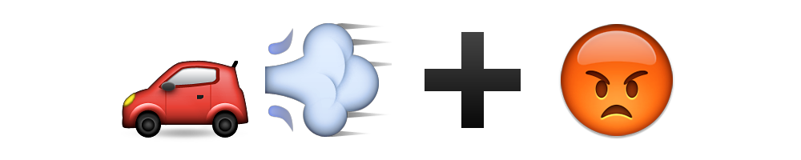

5-
I get up at 🌇, me 🛀, me 👟, 🍳 and prepare to go to 💪. Upon arrival 🏃 and I start doing what the coach tells me, when I finish, I start doing 🧘‍♂️, then I take 🍎 and go to 🌆.

