DIBRA ELISABETTA, ITALY NAMING EMOTIONS
TASK 1:
- anger fear
- anticipation or expectancy surprise
- joy sadness
- admiration disgust

TASKS 2,3,4,5,7: THE WHEEL
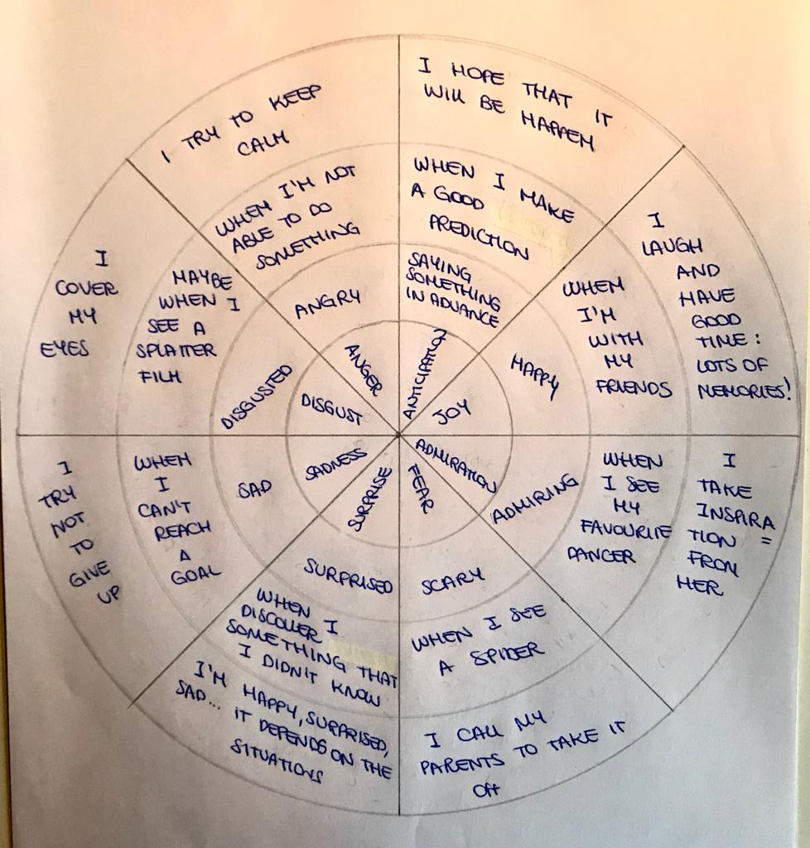

TASK 6:
She is happy because she is listening to music.
She is sad because she has just overthrown milk on his homework.
She is angry because she has just destroyed the castle of cards.
She is disgusted because she has just killed an insect.
She is scared because she has just seen a spider.
I can say that becuase of her reactions.
TASK 8:
He is angry because someone threw him something.
She is bored because she is queuing.
She is excited because she is having fun on roallercoaster.
He is happy because he is going to get on the carousel.
He is hungry because he hasn’t eaten yet.
He is sad because he isn’t tall enough.
He is scared because he has just seen a skull.
She is shy becuase she is ashamed to talk to strangers.
She is sleepy becuase she is tired.
She is thirsty because she hasn’t drunk yet.
He is tired becuase he has looked after the children all day.
She is worried because her friend has fallen.

