Gioele richiardone, Pinerolo:
Naming Emotion
Task 1: Opposites
Anger fear
surprise anticipation or expectancy
joy sadness
admiration disgust
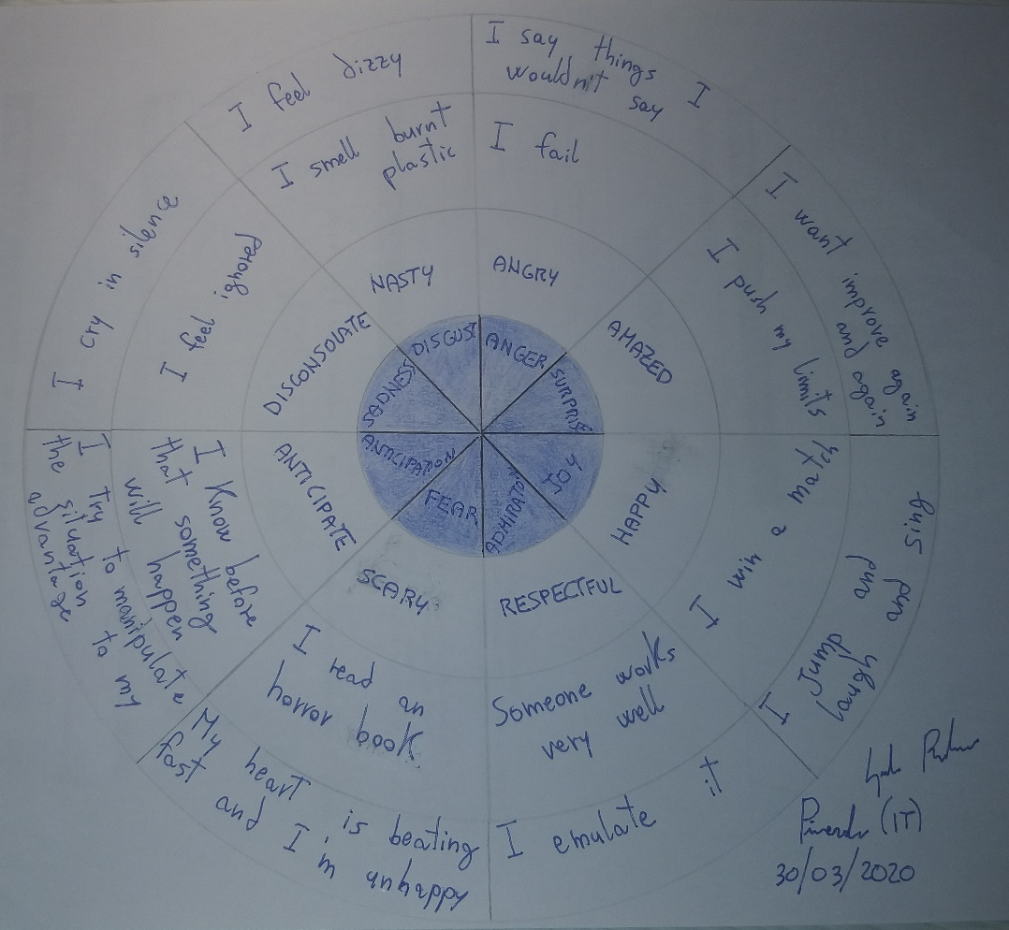
Task 6: Inside out
She is happy because everything is good
She is sad because something she didn’t want happens
She is angry because she made a mistake
She is disgusted because she see an insect
She is scared because she see a spider

