E-TWINNING: NAMING EMOTIONS
TASK 1:
anger fear
surprise anticipation or expectancy
joy sadness
admiration disgust
TASK5:
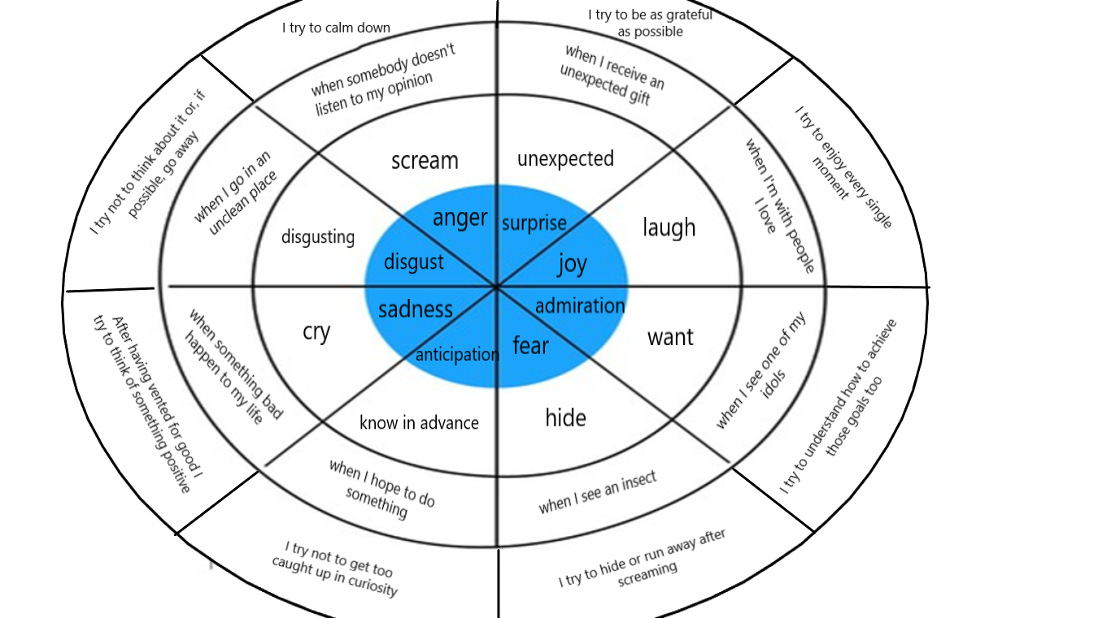
TASK 7:
- He is angry because someone hit him with a can
- She is bored because she has to wait 60 minutes
- She is excited because she is going on a roller coaster
- He is happy because he is about to go on a roller coaster
- He is hungry because he has just seen a snack stand
- He is sad because he is too small to go on a roller coaster
- He is scared because he has just seen a very scary skull
- She is shy because a clown has just offered a rose as a gift
- She is sleepy because she ran all over the funfair
- She is thirsty because she hasn’t already drink nothing
- He is tired because he ran all over the funfair with his children
- She is worried because her friend has just fallen down

