ADJECTIVES-EMOTIONS E-TWINNING BRAMANTE FASANO FEDERICA-ITALY

- Anger Fear
Joy Sadness
Admiration Disgust
Anticipation/Expectancy Surprise

MY EMOTIONS WHEEL
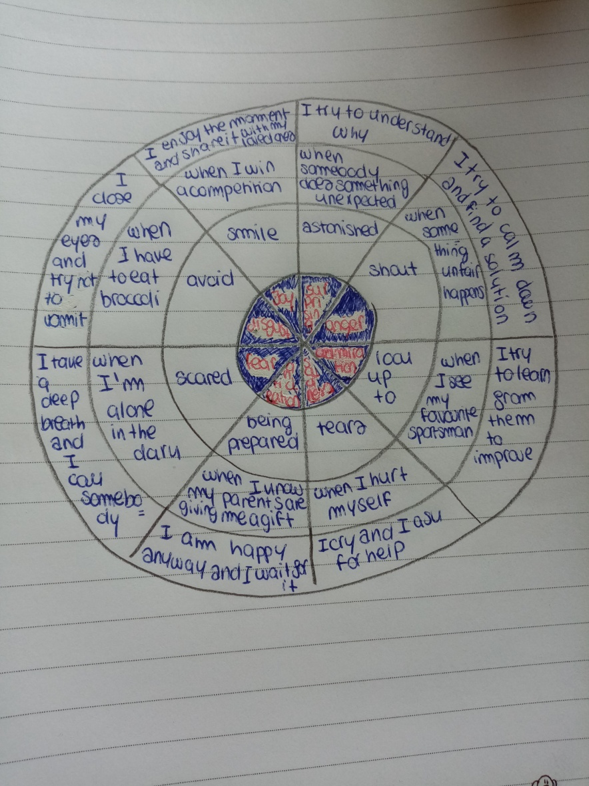

6) Joy, sadness, anger, disgust, fear: you understand that because of her reactions.
Task 8
He is angry because someone threw him a can. She is bored because she is queing. She is excited because she is on a sort of roller coaster. He is happy because it’s his turn. He is hungry because he hasn’t eaten yet. He is sad because he isn’t tall enough. He is scared because he has seen a skull. She is shy because she doesn’t want to be seen. She is sleepy because she has played all day. She is thirsty because she hasn’t drunk yet. He is tired because he has babysat the children all day. She is worried because her friend has fallen.

