ADJECTIVES-EMOTIONS E-TWINNING Ferroni Milena

1. ANGER – FEAR
ANTICIPATION / EXPECTANCY – SURPRISE
JOY – SADNESS
ADMIRATION – DISGUST

TASK 2

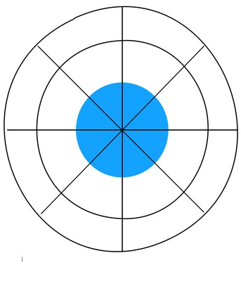
TASK 3
-SADNESS : unhappiness,dreariness
-FEAR : scare,fright,panic,dread
-ANTICIPATION or EXPECTANCY : expectancy,forecast,prevision,to provide
-ADMIRATION : appreciation,to admire,to appreciate
-JOY : happiness,felicity,to rejoice
-ANGER : rage,wrath,to irritate
-SUPRISE : wonder,amazement,to wonder
-DISGUST : distate,dislike,to nauseate

TASK 4
- I am sad when I get bad marks,I fight with someone and I think that I'm not be able to do my best.
- I am afraid when I see skeletons and I watch horror films.
- I make predictions when other people told me about something before.
- I admire the people that help the others and they aren't too selfish.
- I am happy when I get good marks,I go cycling,I go swimming,I makeup and I do what I love.
- I am angry if someone bothers and doesn't respect me and others.
- I am amazed when I see or do what I never thought to see or do.
- I am disgust if I ate foods that I dislike,in fact I eat only foods that I like,and when I see or become awake of terribile,inhumane things.

TASK 5
- When I am sad I listen to music,I watch TV and I go cycling or swimming.
- When I am afraid I stay with other peeple and I try to distract me,so I think positive.
- When I make predictions I am alone and I use my imagination.
- When I admire someone I am usually watching a film or TV, or I see that he is helping others, so I think that he is very strong and an example for everyone.
- When I am angry I try to stay calm,in fact I do what I love and relax me.
- When I am amazed I am usually watching a film or a TV series or a music video.
- When I am disgusted I eat my favourite foods,like ice-cream or pizza or apple cakes,and I try to help others.
TASK 6
The girl is happy,then sad,then angry,then disgusted and then scared : we understand her feelings from her
behaviors.

TASK 8
    - He is angry because a girl threw an apple core in his head.
    - She is bored because the bus will come to the bus stop one hour later.
    - She is exited because she is going on the roller coaster in the funfair.
    - He is happy because he is going to get on a beautiful corousel.
    - He is hungry because he is seeing the snack stand with lots of good foods in there.
    - He is sad because he isn't enough tall to get on the carousel.
    - He is scared because he is seeing a skeleton.
    - She is shy because a clown is giving her a rose.
    - She is sleepy because she ran everywhere in the funfair before.
    - He is thristy in fact he is dreaming a cola can,then he drink it.
    - He is tired because he is looking after is looking after his children.
    - She is worried because her friend have just fell down.

