GOZZELINO FRANCESCA ITALY 29/03/20
E-TWINNING: NAMING EMOTIONS
TASK 1
anger fear
anticipation or expectancy surprise
joy sadness
admiration disgust
TASK 2-3-4-5
everything seems better to me
I stamp my feet on the ground
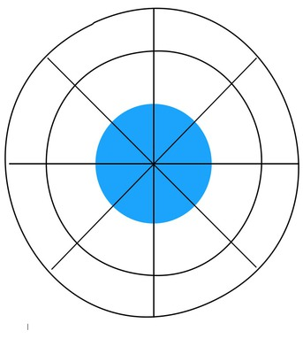
I exclaim: “Oooh”
I’m quiet
my face turns green like Shrek
I hide my face in my hands
my eyes are shining
I blow my nose
after studying
when I hope to get a good mark
artistic gymnastics
when someone dear to me dies
vegetable soup
when my mum cooks me a cake
an horror film
when I’m wrong in something
when I stay with my friends
prepared
smiling
turn red
wonderful
happy
cry
vomit
tremble
anticipation or expectancy
sadness
surprise
admiration
fear
disgust
joy
anger

TASK 6
- She feels joy, so she beats in time on the table and on the cup with pens.
- She feels sadness because she poured the milk on her exercise book, I can say this watching her face.
- She feels anger, she throws the cards on the ground.
- She feels disgust, so she makes a disgusted face and she sticks out her tongue.
- She feels fear because she looks a spider, so she falls of her chair.
TASK 8
- He’s angry because a can hits his head and it makes him a swelling.
- She’s bored because she had to wait an hour.
- She’s excited because she’s doing a funny roller coaster.
- He’s happy because he is about to get on the carousel.
- He’s hungry so his stomach is grumbling.
- He’s sad because he’s not tall enough.
- He’s scared of the skull.
- She’s shy when the clown offer her the rose as a gift, so she’s hiding.
- She’s sleepy because she stretches herself and yawns.
- She’s thirsty so she wants a cola.
- He’s tired because looked after the children at the luna park.
- She’s worried because her friend trips, hurts his knee and started crying.

