TASK 1
- Anger fear
- Disgust joy
- Sadness admiration
- Anticipation surprise

TASK 2,3,4,5
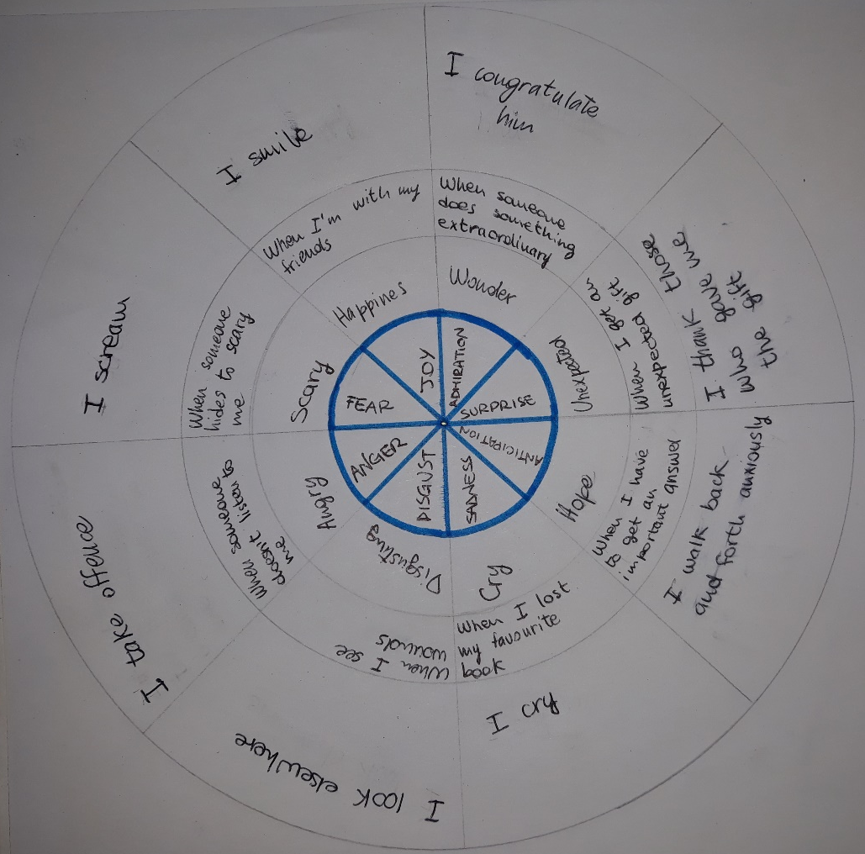

TASK 6
- Joy
- Sadness
- Anger
- Disgust
- Fear
I can understand it from her reactions
TASK 7
- He is angry because something has hot him
- She is bored because she has been in line for a long time
- She is excited because she is going on a roller coaster
- He is happy because he is about to get on the carousel
- He is hangry because he has seen snack
- He is sad because he is too smaller to get on carousel
- He is scared because he has seen a scary skull
- She is shy because a clown she doesn’t know gave her a rose
- She is sleepy because she run all day
- She is thirsty because che has no drink
- He is tired because he had to run with the children
- She is warried because the child is fallen

