Team n°2 : Organisation of the territory

Légende :
River secondary circulation road
Sea primary circulation road
Plains development link
Central space primary tourism area
VENDEE Department
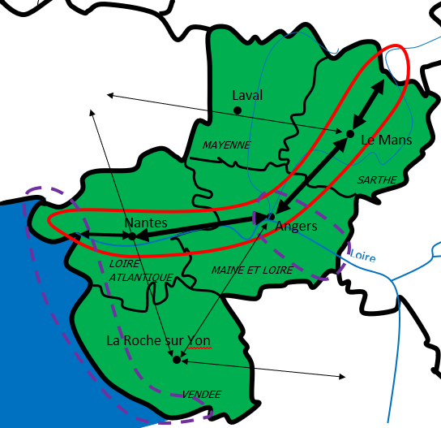

Main numbers :
There are around 3 700 000 inhabitants in Pays de la Loire. The agricultors represent 2.4 % of the population, the head of company : 6%, intelect profession : 11.5%, iterim proffession : 16.6%, employees : 9,9%, worker : 24.5% and retired persons : 25,1%. The half of the population don’t have any chlidren.
Quizz :
1 - How many people are there in Pays-de-la-Loire ?
- Around 1 000 000 inhabitants
- Around 3 700 000 inhabitants
- Around 37 000 000 inhabitants

2 – What is the Pays-de-la-Loire’s central space ?
- Roche-sur-Yon
- Paris
- Coëx

3 – Which city the primary circulation road get through ?
- Nantes / Angers / Le Mans
- Roche-sur-Yon / London / Laval
- There isn’t a primary circulation road

4 – Where is the primary tourism area ?
- Near the sea
- In the middle of the region
- At the Est

5 – How many departements are there in Pays-de-la-Loire ?
- Only 2
- Maybe 8
- Or 5
- It could be 6
- But I think it’s 4
- No, It could be 3

