Computer and internet

About me
Hello, my name is David, I study IT at the Secondary School of Electrical Engineering and I’m going to speak about computers, Internet and information technology. My first topic will be about a Czech programmer.

Czech IT
Czech programmer Marek Rosa (creator of Keen Software House) has invested over 9,222,500.00 € to AI (artificial intelligence).
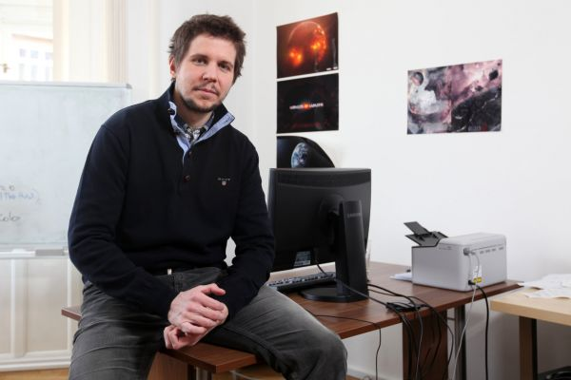

He’s working on the basics of the AI, which will be able to analyze a situation, recognize patterns and make decisions. Now he does it on computer games. The AI that he wants to make can learn, decide and generalize
by itself. Maybe we can have fully automatized robots in a few years.

And what about you? Are you interested in computers and internet and have you already tried to write something?

Have

