Festivals 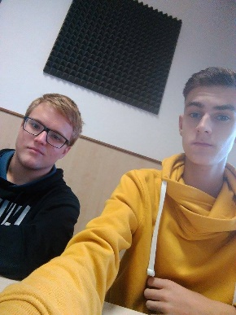

Hi. We are students of Secondary school electrical Úžlabina . We will write about festivals in Czech Republic. Our name is John and Alex.

17th November
The Velvet Revolution was a non-violent transition of power in Czechoslovakia. On November 17, 1989 (International Students' Day), riot police suppressed a student demonstration in Prague. If we celebrate this festival, we don’t go to the school.
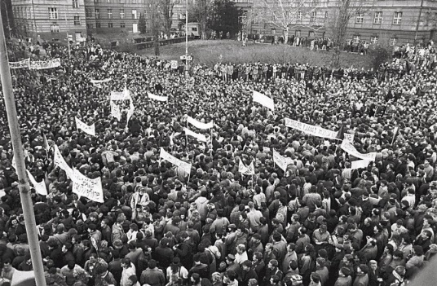
28th October
The creation of Czechoslovakia was a process which led to the establishment of independent Czechoslovakia. Czechoslovakia was declared independence on 28 October 1918. This is our traditional festival.
Czech people celebrate this festival at home.
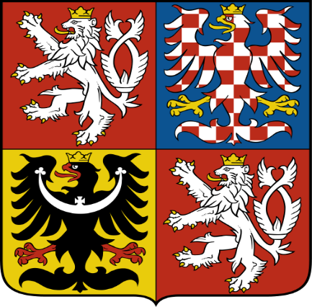

Sources:
https://en.wikipedia.org/wiki/Velvet_Revolution
https://cs.wikipedia.org/wiki/Vznik_%C4%8Ceskoslovenska
Do you celebrate these festivals ?

