Sports
Libor Bednar David Laube
We would like to share with you Fotball in the Czech Republic.
Football: Fotball is the most popular sport in the Czech Republic.
We will talk about popular teams in the Czech Republic.
AC Sparta Praha: Sparta is the best team in Czech Rep. Some players from the team are in the repre. Of Czech rep. This team is most popular in Czech Rep. If you want to see them you must buy a ticket. It will cost about 400 Kč. They are playing Synot league. And thay are wining it.
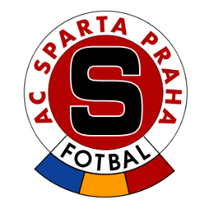
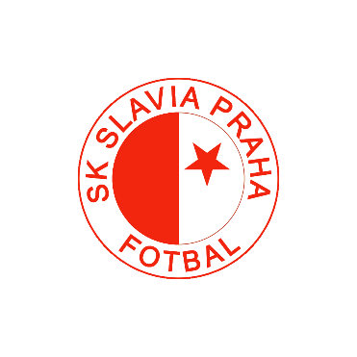
SK Slavia Praha: Slavia is the third most popular team in Czech Rep. They are in the fight with Sparta. Ofcourse they want to win. But thay are not better then Sparta. They are playing to Synot leauge.

Bohemians: Bohemians is the second most popular team in Czech Rep. They are also playin Synot league.

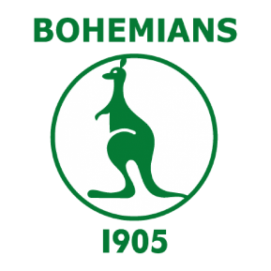
What you and your football clubs in your country?

Sources:
https://cs.wikipedia.org/wiki/AC_Sparta_Praha
https://cs.wikipedia.org/wiki/SK_Slavia_Praha
https://cs.wikipedia.org/wiki/FC_Bohemians_Praha

