Our names are Nuri and Sigi.
We will deal with latest science innovations in the Czech Republic.
We hope that you will enjoy it.

Scientists from the Brno University are working on a magnesium replacement of bone, which itself absorbed.
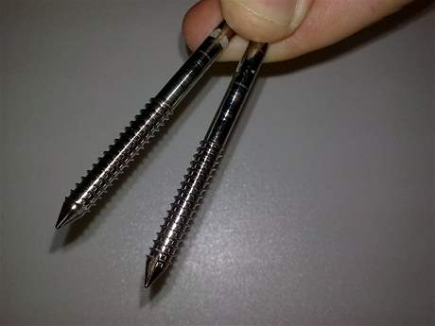Instead of steel screws and wires could be in the future joining the crushed bones to help lightweight magnesium alloy. Their research chemists from the Brno University of Technology are working. In the laboratory metal corrosion and now they are looking for the ideal composition of the alloy, which is gradually absorbed in the body. There would be not such need several operations.
If it is needed comminuted large part for large bones, thigh, calf or other bones, so it is replacing by magnesium composite. Over time, magnesium and other metallic elements is absorbed by and remains there only bone itself, which it has a regenerative ability.

Do you think, that magnesium replacement will be successful idea?
Have you ever been in Brno??

Sources:
http://www.rozhlas.cz

