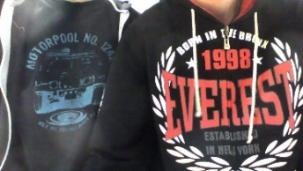
Our photo

Culture
Hello and welcome in our first journalistic article. We are boys from Czech secondary school SPŠE V Úžlabině! I am Michal and Thomas is here with me! We´ll supply you all kinds of canards! We hope that you´ll enjoy our articles of Czech culture and that you´ll be happy and mesmerized by them!
Czech Art Nouveau

The main impersonator of Czech Art nouveau is Alfons Mucha (1860 – 1939). Awareness of the work of this painter quickly spread beyond the borders of the Czech lands. He also designed theater programs and posters in the 1890s for the actress Sarah Bernhardt and her Renaissance theatre in Paris.
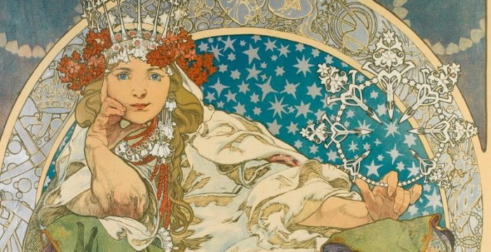

You can find an example of Art Nouveau sculpture on Prague´s Old Town Square on Jan Hus monument or on the statue of František Palacký. These are monumental works beyond comparison in Czech sculpture.
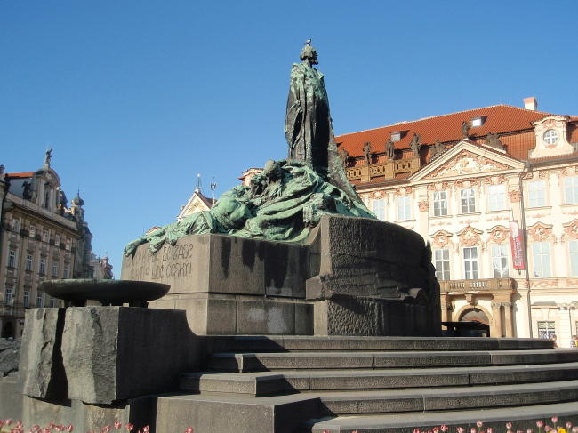
Master Jan Hus monument on Old Town Square.
We hope that you enjoyed our article and that we entice you to visit the Czech Republic and Prague. We think it´s worth it!
Do you like Czech art or you think that your land have better art?

