DLH
DLH is a Danish owned group quoted on NASDAQ OMX Nordic and since 1908 trading in timber and timber products all over the world.

100th anniversary
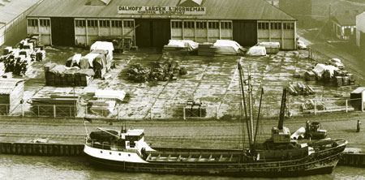

The DLH-Group celebrated its 100th anniversary in 2008.
We look back at a history not only about wood, but more importantly about the people who created the business and expanded it. It is about vision, innovation and skills in good times as well as in bad times. Strategic thinking is evident throughout as is the courage to strike out world-wide; the Vikings of our day. And demonstrating the very qualities stated in DLH’s future-oriented shared values: Professionalism, entrepreneurship and openness – practised responsibly in a global and multicultural world.

We now stand on the threshold of the second century in the company’s history. Our joint passion for wood will be our prime driving force.

Why on earth a wooden house?
Træ er Miljø has released a new cartoon video about wood as the best construction material. The film will premiere at UNs workshop “The Green Life of Wood” i Geneve in October 2012. Click on the picture to watch the film.

Please note that Adobe Flash is required to watch the film. Click on the icon below to download Adobe Flash.

www.dlh.com/

EU Timber Regulation (EUTR): Do you comply?

YOU DO, if you buy timber from DLH.
If DLH is the importer, we will make sure that all our products comply with EUTR. Thus, you do not need to worry about due diligence. You will only need to comply with the requirement for traders within EU, i.e. keep records of your direct supplier and customer.

If you are the importer but have purchased the product from DLH, we will make sure you have access to all the needed evidence to comply with EUTR. Thus you don’t need to worry about due diligence down the supply chain and all the way to the concession of harvest.
We can supply timber compliant with EUTR because since 2002 we have operated a due diligence system called Good Supplier Program. With the latest updates, this program guarantees that every supplier is risk-rated and assessed based on the EUTR requirements.

EUTR Requirements

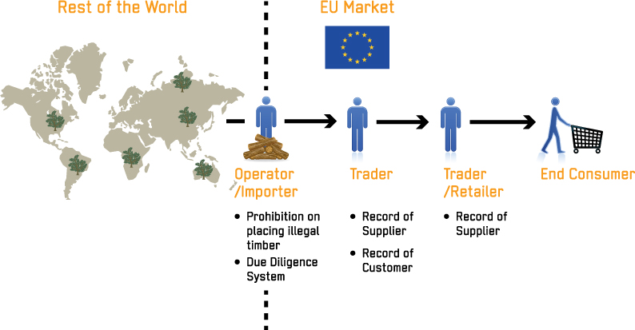

In 2013 DLH was among the first companies in Denmark and Europe to be audited against the EU Timber Regulation (EUTR) requirements. Our new due diligence system, GSP v. 2013 was assessed to be compliant with EUTR. After several years of dedicated work towards improving our supplier due diligence procedures, we can ensure customers and key stakeholders that we are the leading wholesaler of responsible timber.

We operate globally and source wood from tropical, temperate and boreal forests, whose preservation is important for the future of the entire global community.

The world’s forests

Every year large areas of tropical forests are being converted to commercial agriculture due to the increasing demand and rising prices for food, plants oils and biofuels. Deforestation is thus one of the major contributors to climate change accounting for 18% of global carbon emissions.

Illegal and destructive logging activities also threaten the conservation of forests. But forestry activities, if conducted in accordance with local laws and international environmental standards, do not contribute to deforestation. Well-managed forests are forests that can continue to perform the numerous valuable services they provide to the global community: climate regulation, natural carbon sinks, biodiversity protection and contribution to the livelihood of 1.6 billion people.

Therefore, ensuring that the timber we source has been legally harvested constitute one of the major challenges of our business. Our overriding goal is to contribute to the conservation of the world’s forest and battle against climate change by promoting legality and sustainable forest management. We explain how in the following paragraphs.

Acts about DHL’s environmental policy on suppliers

- All our suppliers must commit to and comply with DLH’s environment policy

- In countries where there is a potential risk of non-compliance with this policy, we implement the Good Supplier Programme (GSP, which is the group’s risk-assessment tool. Participation in GSP is a pre-requisite for becoming a DLH Supplier.
- In some supply countries, as a result of a country risk assessment, we have taken extra measures to avoid unacceptable wood. In other cases, we have stopped sourcing completely. The current list of countries with special sourcing guidelines includes Brazil, Burma, Cameroon, Democratic Republic of Congo (Kinshasa), Liberia, Malaysia (Sarawak), Nigeria, Papua New Guinea (PNG) and Sierra Leone.
- We will work with our suppliers on knowledge sharing and capacity building. We will use our position as one of the market leaders in certified tropical hardwoods in order to support them in achieving VLO and FSC certification.

- DLH will investigate the origin of all timber originating in risk countries. Origin is defined by DLH as the forest in which the timber has been harvested.

Important years in our history
2012 | Divestment of Inter-Continental Hardwoods Inc. (ICH), USA
 | New office in Greensboro, USA with sales and distribution of plywood and panels
 | New office in Dubai, United Arab Emirates
 | Transfer of logistics and administrative functions from Denmark to Hong Kong, Global Sales & Sourcing
 | Russia becomes part of Sales Region Central & Eastern Europe
2011 | Divestment of activities in UK and Germany
2010 | Divestment of tt Timber International AG
 | DLH sets new targets in Go To Market strategy
 | Simplification of DLH’s organization and management structure
 | Divestment of Carl Ronnow, Malaysia
 | Sale of activities in I-Dry, Netherland
 | DLH presents the Back to Black strategy.
2009 | Adjustment of the organisation of the Timber and Board Division in Scandinavia.
2008 | DLH opens a new sales office in New Delhi, India.
 | Takeover of the hardwood operation of the Finnish business of Puukeskus OY which is well positioned in the Finnish hardwood market.
 | DLH sells its Danish building materials activities to French Saint-Gobain in order to strengthen its international wholesale business.
 | Takeover of the Swedish company Palma Byggrossisten AB.
2007 | Takeover of the Swedish company Olle Zettergren AB that with its good placement on the Swedish Industry Marked will strengthen DLH's marked position in the North.
 | Takeover of OK Træ ApS in Denmark. Will be a part of the Timber & Board Division.
 | Takeover of the Norwegian company Erling Hustvedt, which have a solid placement in the Norwegian industry market of Hardwood and veneer.
2006 | Danish central warehouse moves from Gadstrup to Køge Harbour, Denmark.
 | Takeover of the Swedish company Karl Ljungberg AB together with the Norwegian daughter company Ljungberg AS.
 | Takeover of Internationalt Hårdttræ in Hovedgård, Denmark.
 | Takeover of Swiss timber merchant company, the tt Timber Group

2005 | Takeover of the hardwood supplier, Risør Træ & Finer, Denmark. Combined with the Walter Jessen's hardwood department in Brøndby, Denmark.
 | Acquisition of Swedish-based Bohmans, distributor of veneer and hardwood in Sweden, Finland and a number of Eastern European Countries.
 | Acquisition of Møller Lee Tømmerhandel A/S with integrated RÅD&DÅD DIY shop in Hjørring, Denmark
2004 | Danish central warehouse moves from Hedensted to Kolding Harbour, Denmark.
2003 | Acquisition of Holten Lange in Ringsted and Køge, Denmark, which are both part of the Building Division.
 | Acquisition of PW Hardwood, USA and Crown, Malaysia, which are both included in the Hardwood Division
 | In the period from 1965 to 1999 approx. 20 timber merchant companies were acquired, which form the Building Materials Division.
1994 | Merger with Walter Jessen & Co. A/S, Denmark.
1986 | Listed by the Copenhagen Stock Exchange.
1983 | 75th anniversary with 438 employees throughout the world.
1971 | Dalhoff Larsen & Horneman becomes a limited company.
1965 | Acquisition of C&N Trælasthandel A/S, Aalborg, Denmark. The foundation of what in 2002 represents the Building Materials Division.
1958 | Harald Kjær & Co. changes name to Dalhoff Larsen & Horneman, Nordisk Træimport.
1946 | International trade in hardwoods (stock-holding wholesaler, agent). The foundation of what in 2002 represents the Hardwood Division.
 | Import of northern timber (stock-holding wholesaler, agent). The foundation of what in 2002 represents the Timber & Board Division.
1935 | Harald Kjær & Co. - Sawn timber wholesale: The management was extended by Knud Dalhoff Larsen and Frees Horneman, who became partners.
1908 | DLH was established in 1908 by Harald Kjær.

