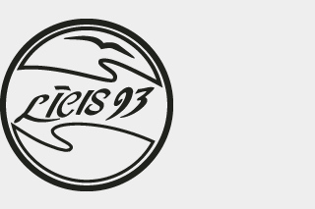
Līcis-93
Kolka workshop

Legal form: Society with limited responsibility

Līcis-93 Ltd is one of the largest producers of canned fish in Latvia.
The company has two fish-processing workshops situated on the coast of the Gulf of Riga of the Baltic Sea in the cities of Kolka and Ģipka.
Līcis-93 Ltd has a fishing fleet that allows for the quick delivery of fresh fish to the factory for processing, thus providing a high-quality production of canned fish.
The main type of production is sprats in oil, which are produced according to old traditions.

Achievements: In 2014 the profit of Līcis 93 Ltd was 1.4 million EUR which is a remarkable increase compared to 447 705 EUR in 2013.
