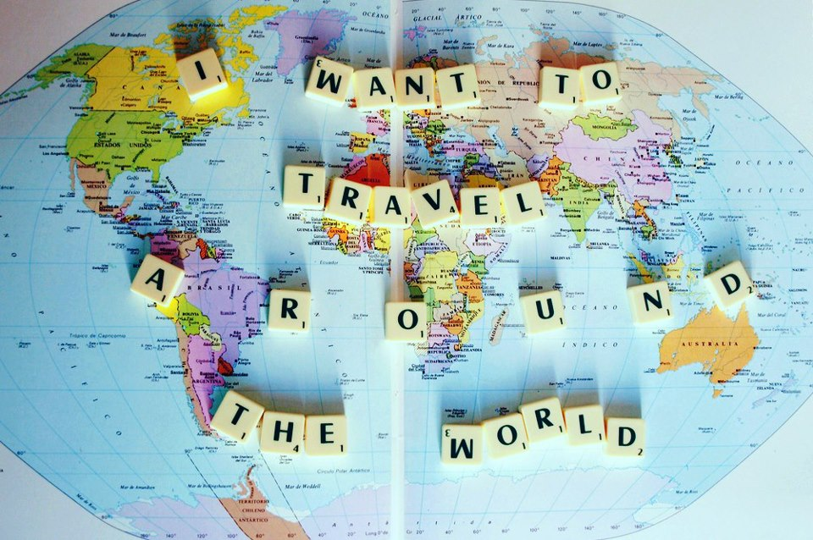

Travel Agency
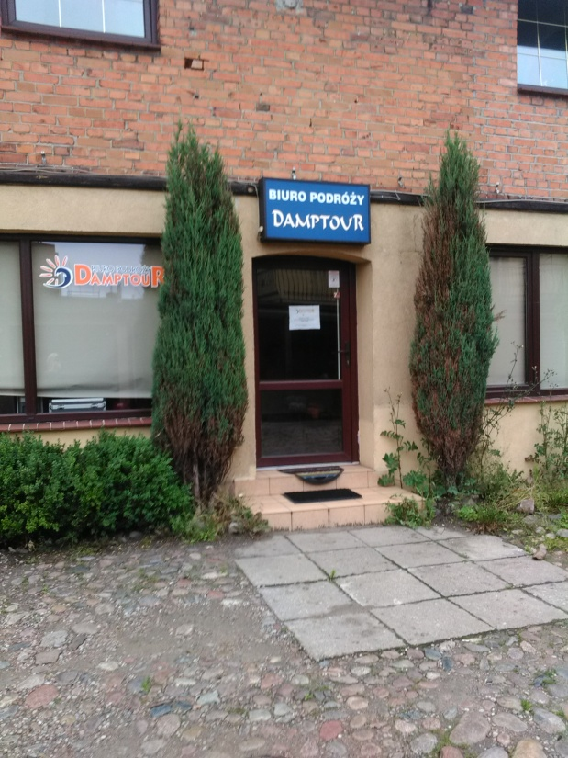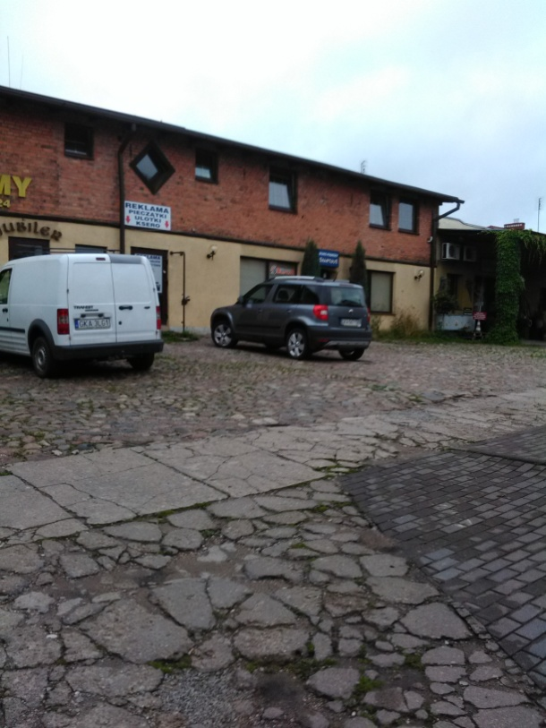

The service company we have chosen is ‘Damptour’ Travel Agency located in Kartuzy. This company offers a wide range of tourist services to its clients. Among other things it mediates the offers of the largest Polish travel agencies, organizes events for groups of various types: leisure, cognitive, integration and school trips. This is a very popular place in our town if you’re looking for touring the country or travelling abroad.

F.H.U.DAMP - Biuro Podróży “Damptour” has been on the tourist market for 25 years. The company specializes in vacationing in destinations such as: Croatia, Greece, Bulgaria and Poland, of course. Teenage camps are also on offer.

The company’s main office is situated, since the beginning, in Bobrowiecka street in Cieszyno, Poland. It has developed greatly and currently cooperates with over 700 agents in the country. Right now it is one of the most recognizable and popular travel agencies in Poland.

Contact:
Address:
ul. Kościuszki 18
83-300 Kartuzy
phone number: +48 58 746 35 50
e- mail: wczasy@damptour.eu

