**My school**

**Hi! My name is Petra. I ´m 9 nine. J go to Bernolakova school. Lock at the pictures.**

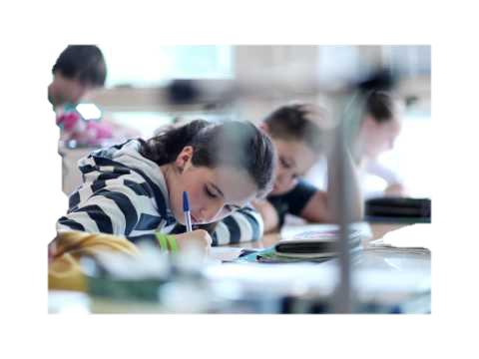

**Our classroom is upstaiss. It´s very big and briht.**

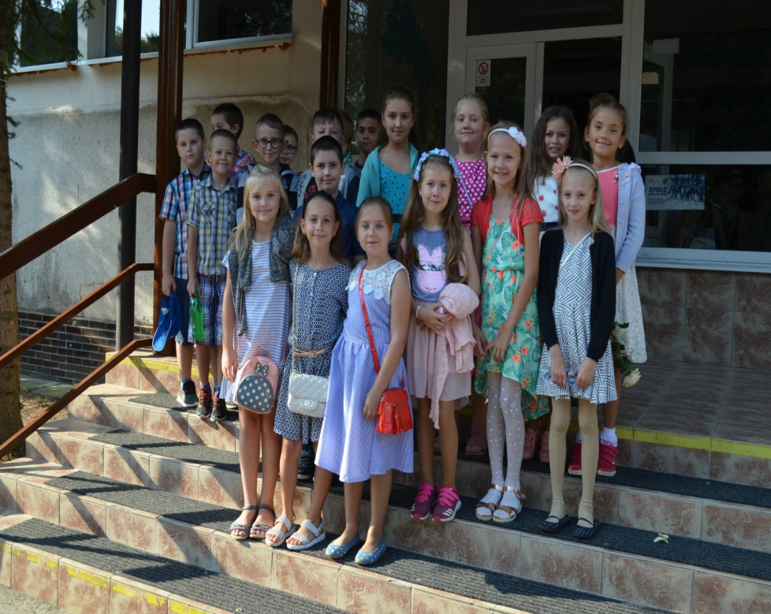

**J´m class 4.B. Trese are 9 girls and 10 boys.**

**Ous teacher is Mrs Maria Polomčákova.**

**These are lots of pictures and posters on the wall.**

**We sita at the tables bles. Next to me sit my friend Matej.**

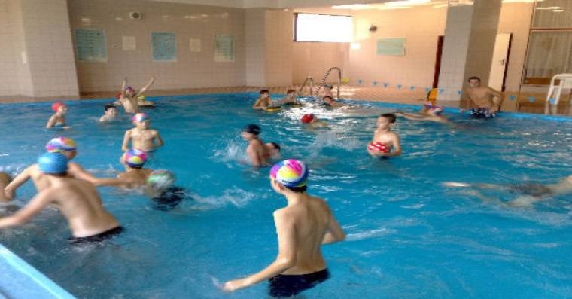

**These is swinning pool.**



**I LOVE MY SCHOOL**