My school.

My name is Karin .

I go to bernoláková school.

Look at there Picture of my school.

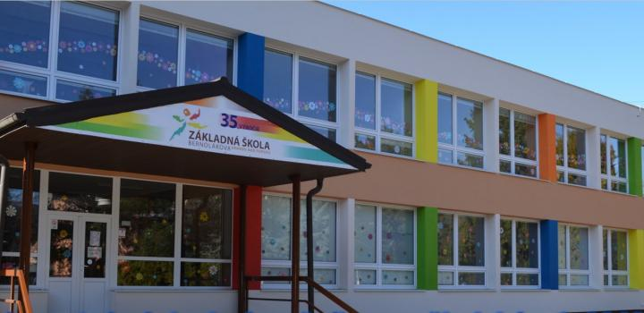

Our classroom is upstairs.

It is very big and bright. I am in classroom 4.A.There are 15 girls and 10 boys in my class.Our teacher is Mrs. Lacka.

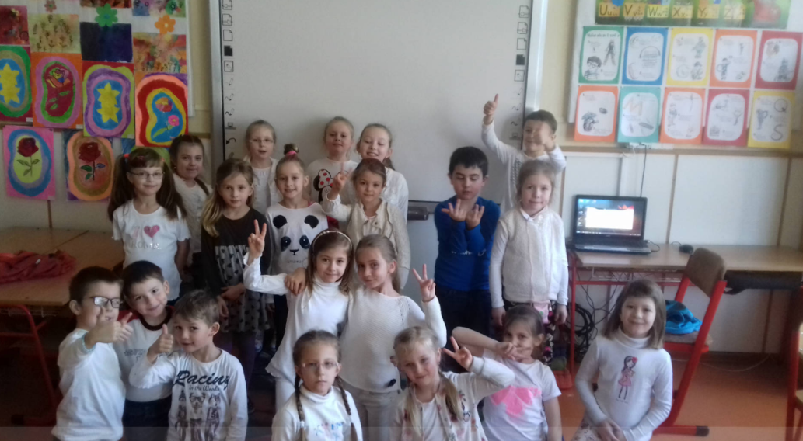

There are lots of pictures on the wall.We sit at table.I sit with my friend Vivien.

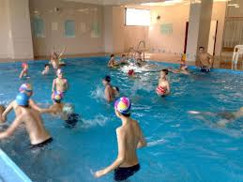

There is a swimming pool ,too.i love my school.

I love my school.