Alicia García – Oct 2018
“A DAY IN THE LIFE OF AN IMMIGRANT TODAY”
Last night, I dreamed that my family and I were still in our country, Syria. I woke up when the sound of a bomb appeared in my head. I can not forget the image of our city and our dear house completely destroyed after the bombing.
In Greece we are safe, this is what we were looking for. However, I miss my parents, my friends, the little shop we owned in the city centre... I think It will past much time until I come to terms with life here.
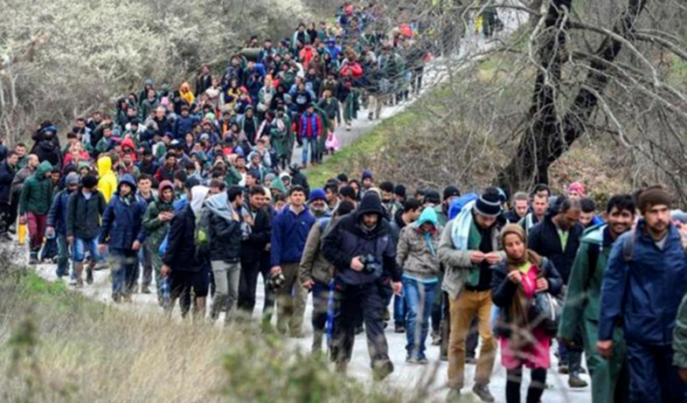
Our way to this country was really hard. In addition, my son (who is only 6 years old) suffered a lot. It was very dangerous when we travelled by patera. It was full of people and we ran out of food. Miraculously, a rescue boat saw our patera and helped us. When we arrived at the country I started to cry of relief and happiness.
After three months since the arrival, my husband obtained a job that allows us to live a decent life. It gives us the necessary money for our house, food, clothes, etc. However, I am still looking for a job in order to have a better quality of life. I hope to find one soon.

My husband and I are struggling with the language, it is really difficult for us. Despite this, our son is progressing incredibly. Moreover, he has made new friends.
Greece is a very beautiful country, we live near the beach and the landscape is amazing. People here are quite nice and they are always trying to help us.

