Lesson Plans: Culture

Lessons on culture were carried out in different classes, different age groups and by different teachers. The following lesson plans, which were published in 2006 by “Teaching Culture!” a Grundtvig 1 project funded by the European Union, were supplied to the teachers but had to be adjusted and customized to the different needs.
For our students an action-oriented approach is the method of choice, an analytical approach serves comparatively few students.

The intercultural interview | Game, warming up, get to know each other, role-play, intercultural awareness, communication

http://www.teaching-culture.de/en/products/lesson_plans/Activity%20-%20The%20intercultural%20interview.pdf

True of false | Discussion about Stereotypes, cultural knowledge / awareness

http://www.teaching-culture.de/en/products/lesson_plans/Activity%20-%20True%20of%20False.pdf

You what? | Nonverbal Communication by Dot Aastrom and Pat Shrimpton

http://www.teaching-culture.de/en/products/lesson_plans/Moderators_new/Aastrom,%20Dot%20and%20Pat%20Shrimpton%20-%20You%20what%20-%20Nonverbal%20communication;%20Lesson%20plan.doc

What do you know about ... country? | warming up, mind mapping before starting lectures about a certain country, facts about culture (history, geography, society)
http://www.teaching-culture.de/en/products/lesson_plans/Activity%20-%20What%20do%20you%20know%20about%20X%20country.pdf

Get to know your neighbours 1 | European stereotypes by Alexandra Haas

http://www.teaching-culture.de/en/products/lesson_plans/Moderators_new/Haas,%20Alexandra%20%20-%20Get%20to%20know%20your%20neighbours%201%20-%20European%20stereotypes.pdf

(More activities are available for download from http://www.teaching-culture.de)

The following activity proved to be particularly instructive and enlightening to our students:

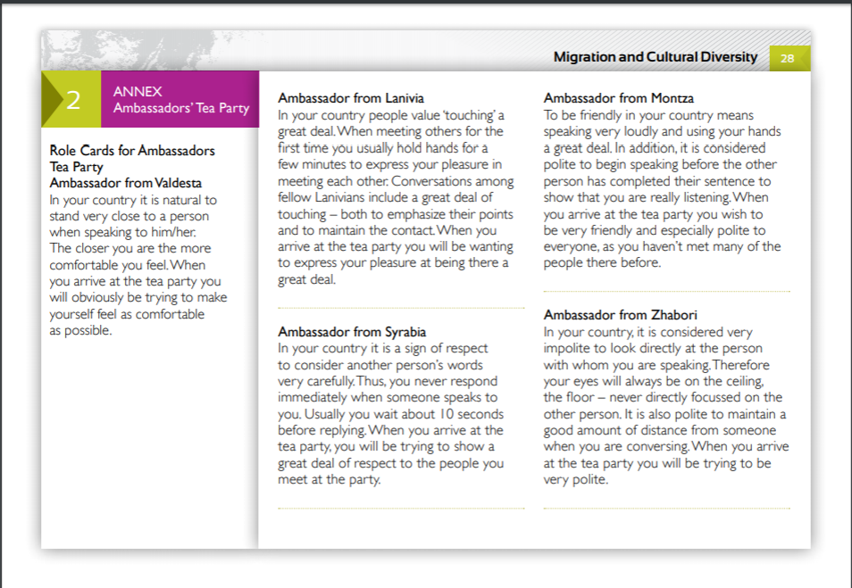
Taken from: Value the difference Resource Pack, SALTO Cultural Diversity Resource Centre, 2016 (SALTO Cultural Diversity is one of the eight SALTO-YOUTH Resource Centres working on European priority areas within the youth field to support the European Commission's programme Erasmus+.)

