WARM-UP GAMES
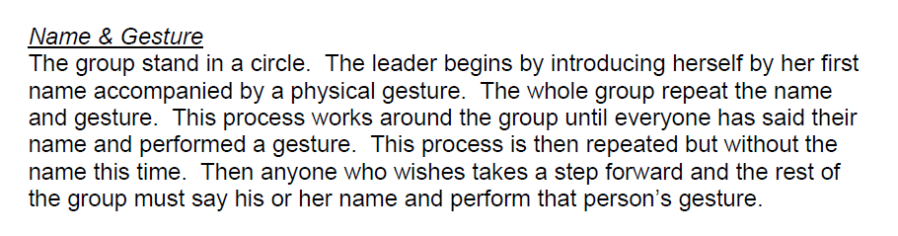
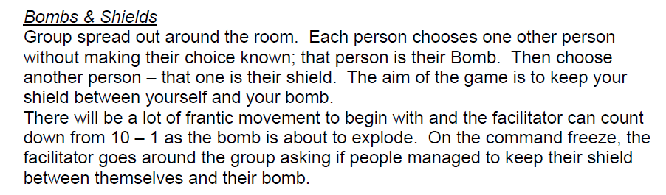
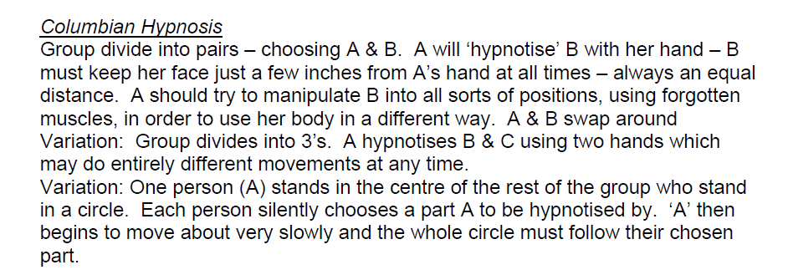
SOUND AND MOVEMENT
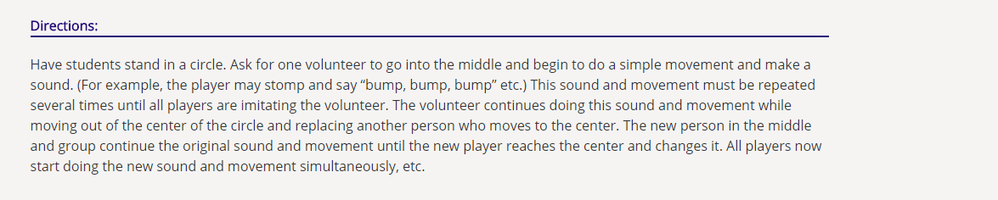

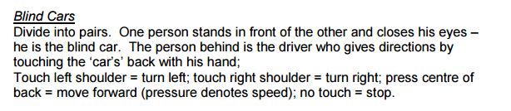
COOKIE
Devide into pairs. One person navigates the other, whose eyes are closed, by saying “Cookie”.
Stage 1: Guide says “Cookie” again and again. When the facilitator says “…..?......” (we can’t remember what exactly we said) the guide moves further away from the partner, the blind partner must find the guide.
Stage 2: Guide can say “Cookie” three time after having moved away from the partner.
Stage 3: Guide can say “Cookie” once.
Stage 4: Guide is not allowed to say “Cookie” any more and must make other sounds for the partner to follow.
