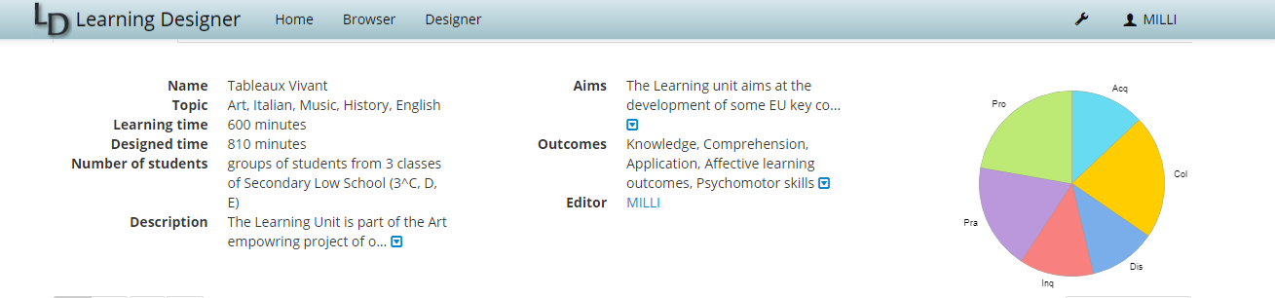

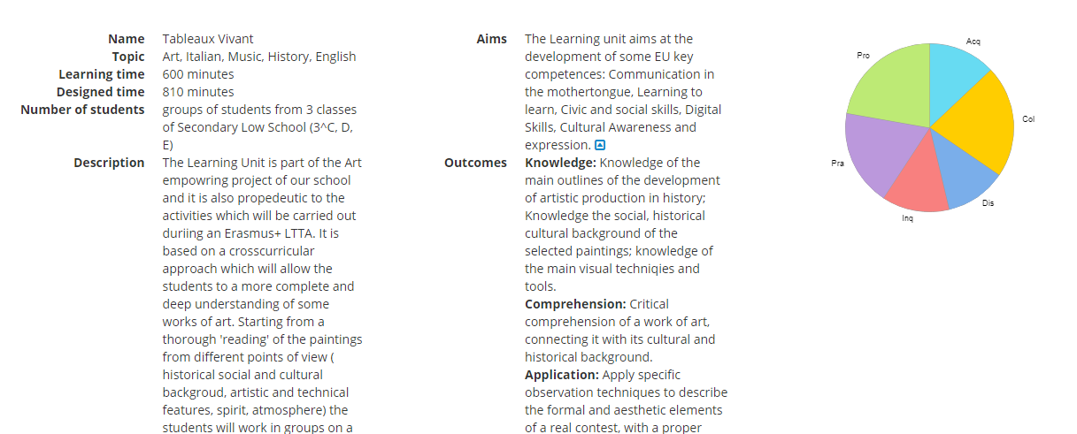

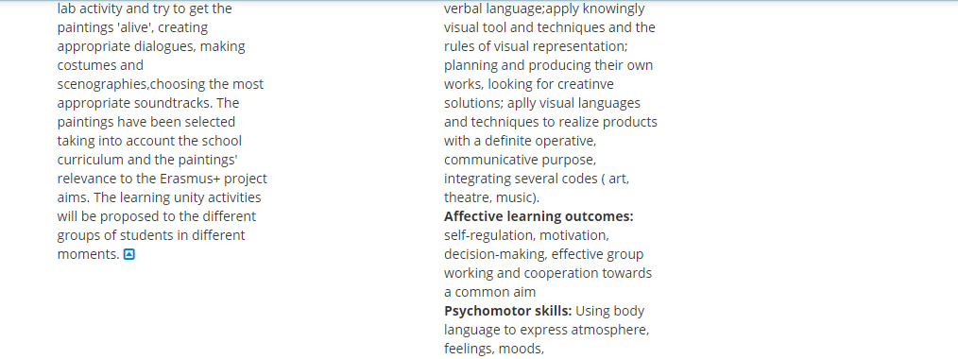

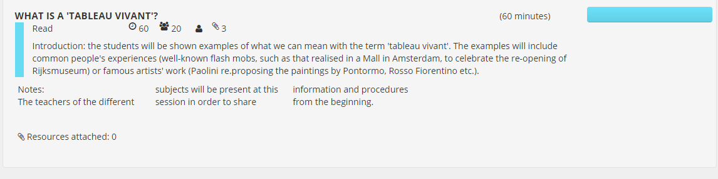

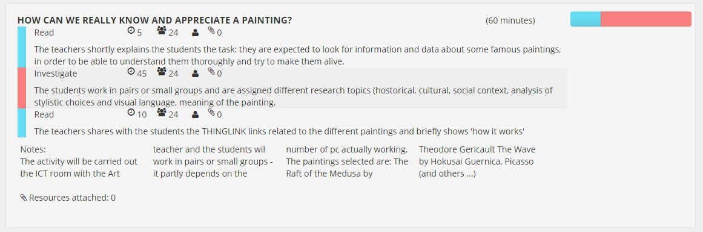

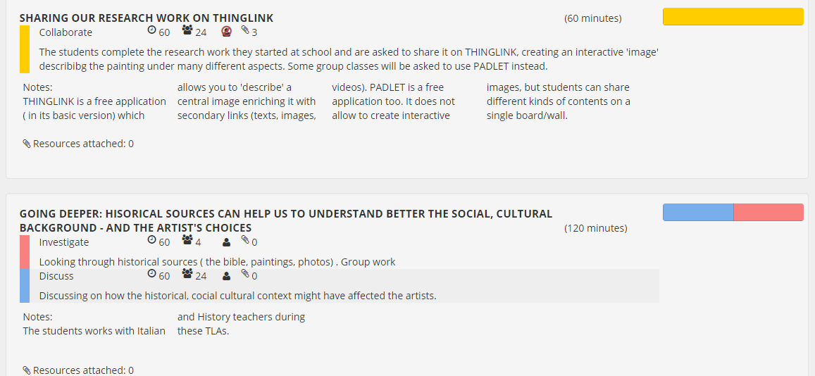

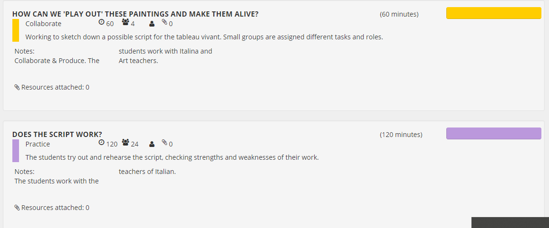

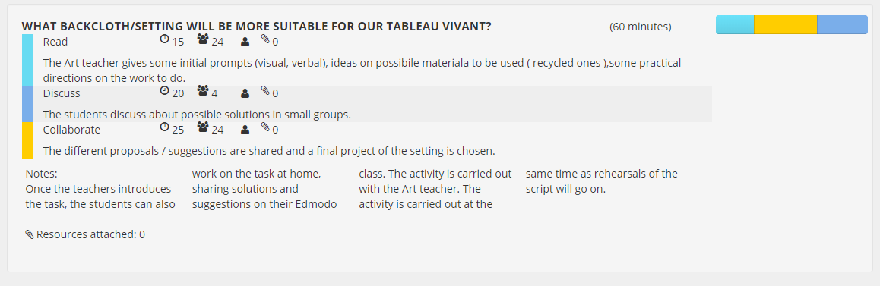

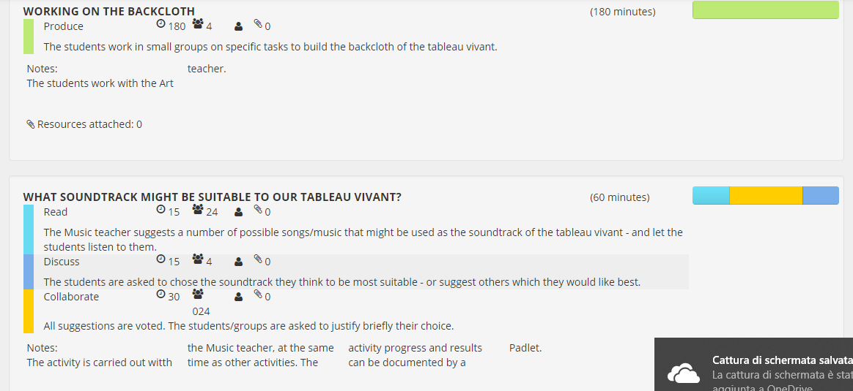

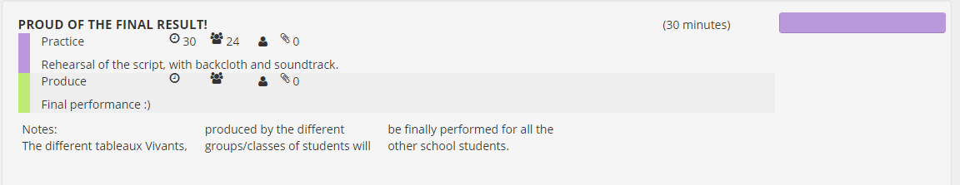

The following one is a link to the lesson plan

<https://v.gd/sqS5wq>

Collegamento interattivo a Thinglink, Guernica

[https://www.thinglink.com/scene/1018799228249440259](https://eur03.safelinks.protection.outlook.com/?url=https%3A%2F%2Fwww.thinglink.com%2Fscene%2F1018799228249440259&data=02%7C01%7C%7C2307f09e09b1429d190008d586786fe9%7C84df9e7fe9f640afb435aaaaaaaaaaaa%7C1%7C0%7C636562774180632738&sdata=p0NRVs4ZFn08rlXN2zXhGa0z8%2F5%2BFXmkAOpjtJjz7Lg%3D&reserved=0)