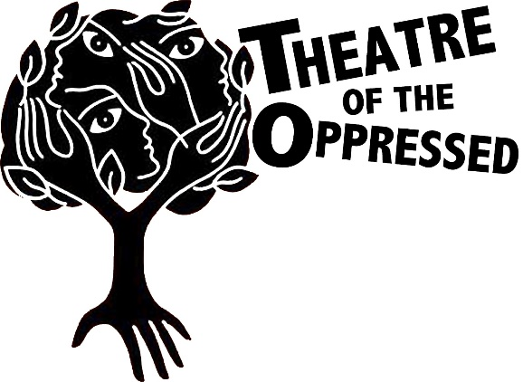
M.I.R.R.O.R.S. LTTA
Cyprus 2017

FORUM THEATRE PLAY

Team work
Decide scenario and roles. Perform a frozen scene. Think what happened before and after this scene. Perform it.
Use the space below for your notes.

