M.I.R.R.O.R.S. LTTA ERASMUS+
CYPRUS 2017
THURSDAY 18 FEBROUARY 2017

Objectives
- Student partner get to know each other
- Make friends and connections
- Cooperate and break the ice between partners

Instructor: Mr Vassilis Papastavrou

Activities

- Name aerobics. The first person can either go to the center of the circle or else stay where they are. Ask the person to introduce themselves by their first name, but instruct them to make some sort of movement or do an action for each syllable of their name. For example: The name “Jonathan " (Jon-a-than) would require that person to make three distinct movements of their choice. Each person in the group repeat the person’s name while also mimicking the actions they performed
- Students just walk around and shake hands saying their names.
- When they shake hands in couple, they also try to shake hands with another student, they introduce themselves and create a team of 3 students.
- Each student gets a working sheet and a pencil. They have to fill in blank spaces with names of partner students that have or own something, i.e. write the names of 4 students (from other countries) that have a dog at home.
- Team play. Players to reorder themselves as quickly as possible.
From shortest to tallest – how many letters are in your first name or in alphabetic order.
From farthest away to closest – birthplace.
From least to most – how many brothers and sisters you have.
Shortest to tallest – height, or shoe size.
Beginning to end of year – birthdates.
- Snowball Fight. Each student is given a piece of paper and told to write five facts about themselves. After they have all written down their facts, tell them to wad the piece of paper and begin a snowball fight. When you think they have thrown enough – or they begin to get carried away – tell them to pick up the “snowball” closest to them, read the facts, and try to find out whose snowball they have by asking yes or no questions only. The first one to do so is the winner. Have the students continue until they have all succeeded.

- Divide the group into pairs. Mirrors. First student acts and the second one has to do the same thing.

- In their pairs student stand at the end of the class. They blow a bubble and try to get it opposite to the other wall by blowing.
- Ballon fights. They try to break a ballon with their bellies.
- Interviews. A group with an odd number of participants can have one group of three, or the odd person can partner with the group leader. Spread out as much as possible so that each partners can hear each other speak. Each group will need to decide who is going to be the “interviewer" and who will be the “subject." Everyone will eventually play both roles, so it doesn’t really matter who goes first. Give the group three minutes for each interviewer to learn three interesting facts about their subject by asking specific questions. Do not allow them to ask, “What are three interesting facts about you?" Good questions examples are: Where did you grow up? What was your favorite class in high school? What do you like to do in your spare time? After three minutes has passed, bring the players together and allow one interviewer at a time to explain what interesting facts they discovered.
- “Hall of fame”. Let’s sing together.

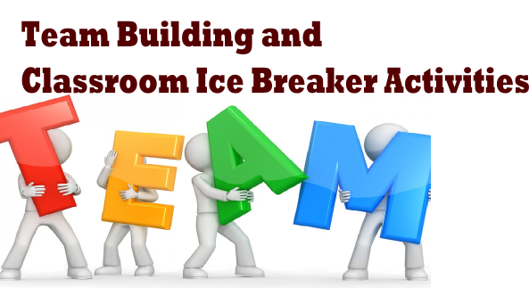
M.I.R.R.O.R.S. LTTA
Cyprus 2017
Find 5 partners from different countries than you, who ….
have a dog | like pizza | don’t like football
love mathematics | take dancing lessons | sing in the shower
enjoy Justin Bieber’s songs | wear shoe size 35 | play xbox

