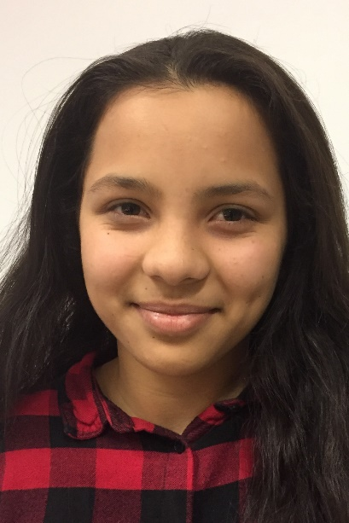

I took clothes and a few photos. But they fell into the sea, so now I don’t have any pictures any more.

What would you like to be when you are grown up?

It didn’t look like Germany to me. I had imagined it to be different, I had expected something else.

Do you remember your first impressions when you arrived in Germany?

In Germany. I would like to spend my holidays in Afghanistan, the summer holidays because of all the nice fruits and the winter holidays because of the snow. But I want to live in Germany.

Where is your home now, in Germany or in Afghanistan?

My dream is to become a nurse, but my marks are not good enough, yet. I really hope that I can make it possible.

What would you like to be when you are grown up?

I took clothes and a few photos. But they fell into the sea, so now I don’t have any pictures any more.

What did you take with you when you left?

I was excited and happy but at the same time I was very sad to leave my family and my friends behind.

How did you feel when you found out?

Yes, I went to school in Greece for three months. It was really hard in the beginning because I didn’t speak the language. But I had a friend, we shared a room at the camp and we were in the same class. She often translated for me and I learned Greek really fast.

Did you go to school in one of these countries?

Did your parents explain to you why you had to leave? home?

From Afghanistan we took a plane to Turkey. Then we went to Greece by boat. From there we took a plane to Denmark, and finally we went to Germany.

We tried eleven or twelve times to cross over to Greece from Turkey. Again and again we boarded a boat, put out to sea, were caught and sent back to Turkey.

During our second boat trip I fell into the sea. It was dark and before my brother could find somebody to help, the boat was already quite far away. I can’t swim but luckily I was wearing a life jacket, so I didn’t drown. A young man jumped into the water and rescued me. But again we didn’t make it to Greece

In the boats that we took there were about 50 people plus some luggage.

When we finally arrived in Greece my mother got very ill. At that time we were in refugee camp and we were not allowed to go outside. An ambulance came and took my mum to hospital. After a few days my brother and my sister and myself joined my mother in hospital, we were given a room there.

Did you pass through other countries on your way to Germany?

In 2015, in August. I was 12 then.

When did you come to Germany?

From Afghanistan

Where are you from?

What was your life like in your home country?

We lived in the capital of Afghanistan, in Kabul. We had a nice house and a big garden, so we always had really nice fruits.

When bombs exploded in the distance you could hear it and see it. It was terrible but luckily there were no bombings near our house. One of my cousins was outside when a bomb exploded, but luckily he survived.

I went to school for 4 years

My father left Afghanistan when I was 3 or 4 years old. He went to Germany. I only saw him once when he came to visit, but I didn’t really know him.

But I always knew that one day we would also go to Germany. But then suddenly my mother told us that we would leave in a week’s time. We just had enough time to say goodbye to our relatives, but I couldn’t say bye to my friends at school.