QUESTION 1:
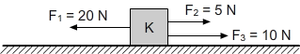

In the figure above, the forces applied to the body (K) are shown to be in the same direction.
What is the force and direction applied on the body? (the issue of friction is unimportant).

QUESTION:2

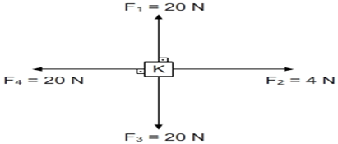

The body(K) is in the exposure of four forces as you can see above(the issue of friction is unimportant).
According to this,what is the direction of the resultant force and its size?
QUESTION 3:
(Velocity)
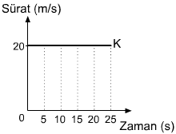 (Time)
Look at the Body (K) in movement in the Velocity- Time graphic and How much meters does it(Body K) take in 25 seconds?
QUESTION 4:
House School
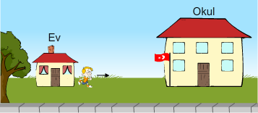

Kemal would like to measure the distance between his house and his school. For this reason, Kemal takes equal steps in a straight line until he reaches his school and counts each step. Kemal reached 500 steps when he arrived at school.
If each step that Kemal took is 60 cm long, what is the distance in meters between his school and his home?

QUESTION 5:
The digestive organs and structures are numbered below.
- THE FOOD PIPE
- OESOPHAGUS
- STOMACH
- LARGE INTESTINE
- SMALL INTESTINE
- ANUS
Place the digestive organs and structures listed above in the correct order according to when a nutrient is consumed in the mouth and until it is digested.
QUESTION 6:
Place the planets in our solar system in the correct order according to their distance from the sun.

QUESTION 7:
Fill in the blanks with the correct words
1.The weight unit is……………
2.The mass unit is……………..
3.The mass is measured by……………….

QUESTION 8:
According to the picture, K,L,M objects are weighed by a dynamometer at the same circumstances and their mass is 2m, m and 3m respectively. Object K weights 100N so How much do N,L and M objects weigh?
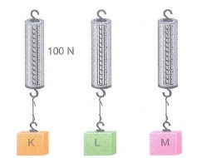

QUESTION 9:
‘Gravitational force of Earth is 6 times more than in Moon’
According to this,How much does an 60N object in Earth weighs in the Moon?

QUESTION 10:
Match the Matters with the Concepts

Matter Concept
1.Table salt a.Solution
2.Ayran b.Compound
3.Cologne c.Heterogeneous mixture

