Music across Europe
“Music gives a soul to the universe, wings to the mind, flight to the imagination, and life to everything.” – Plato
Music is the soundtrack of our lives and in fact 82.4 of the students in the project listen to music” always”, and it is not a joke because we listen to it(72.6) also when we are doing our homework. Many of us (58.8) can play an instrument mostly the piano, but we have some guitarists and one men show -piano, flute, and guitar that’s a lot for sure.We like Pop music , but classic(11.8) is not bad, we like also jazz, rap and rock . We like our anthem ( 82.4) and we consider it really important. Music makes us feel happy, relaxed, emotional and energetic a mixture of emotion that’s why music is so important for us. If we would decide to start a band it would be a pop/rock band quite for sure. We have so many favourite songs that ‘s really difficult to choose one. We listen the radio , and the music we like is sang in English. We think that music can help make world peace because “music is the key to everything” , “ music can change people’s opinion” and “ can help to communicate “ “tell us a message and help spreading it “ so music has the power to find the right way.
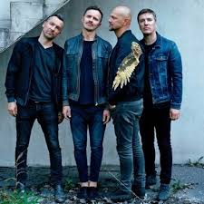
In Latvia the best group is Prāta Vētra,
but if you would like to listen some traditional songs Auga is what you are looking for https://youtu.be/EgtTEtu20F0.

In Portugal the best singer is Amália Rodrigues and the best traditional song is Uma Casa Portuguesa https://www.youtube.com/watch?v=RU-Z0SiQKgU
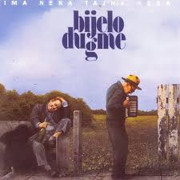

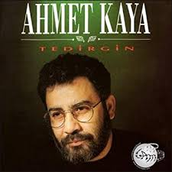
In Croatia the best group is CRVENA JABUKA AND BIJELO DUGME; and the best traditional singer is Oliver Dragojevic, Doris Dragovic https://youtu.be/4lWgvFQX2MM

In Turkey the best singer is Ahmet Kaya , but for traditional song you have to listen to Barış Manço - Yaz Dostum

In Italy we like Irama https://www.youtube.com/watch?v=jPDAsvJndME, and Alessandra Amoroso
https://youtu.be/fHFx6FbUMRQ. Speaking about tradition we like tarantella and the National Anthem

So “ music is life itself “- Louis Amstrong , stop reading and listen one of this awesome song .
“Good Act Epidemic” students

