GREECE, 5TH GENERAL SENIOR HIGH SCHOOL OF AIGALEO
DISSEMINATION ACTIVITIES (01.09.2020-31.08.2021)

Ι. We chose fb posts as a means of dissemination, both because of the pandemic and because we want multiplied benefits through our notifications:
1. Educational fb, such as the private team West Side Culture (managed by Ms. Ioanna Dekatri, Head of Cultural Affairs of the 3rd Directorate of Athens) and public groups, such as the School of Creativity and Young Active Eurocitizens (managed by Ms. Ioanna Dinou (Head of Environmental issues of the 3rd Directorate of Athens)
Α. Activity 1:17 April 2021 West Side Culture
C10-Short-term exchanges of groups of Pupils “Get in Shape for Europe ... in Romania”
(14-16 April 2021):
https://www.facebook.com/groups/young.active.eurocitizens

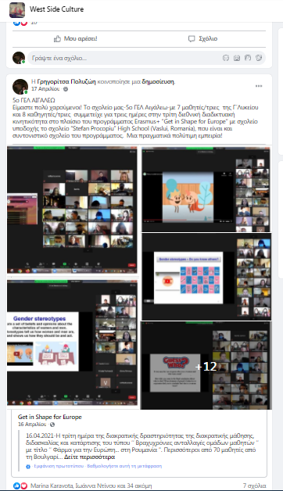

B. Activity 2: 17 April 2021 School of Creativity
C10-Short-term exchanges of groups of Pupils “Get in Shape for Europe ... in Romania” (14-16 April 2021) :
https://www.facebook.com/groups/117723188973492/?multi_permalinks=1024414924970976

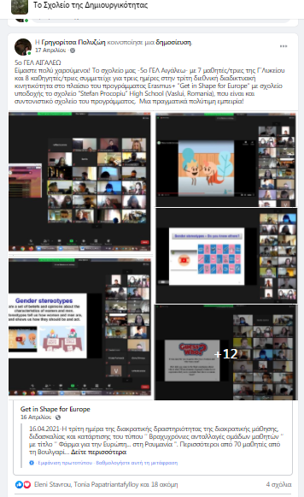
C. Activity 3: 17 April 2021: EU in 12 Words -Υoung Active Eurocitizens

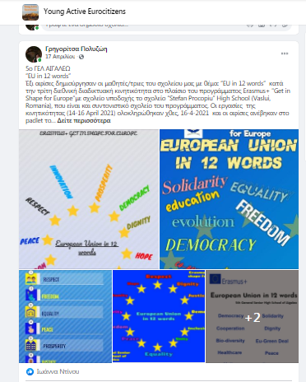

2. The fb of the State Scholarships Foundation
D. Activity 4: 18-6-2021 4 online meetings (2 for students and 2 for teachers in Romania and Poland
https://www.facebook.com/StateScholarshipsFoundation/posts/4294560407255204

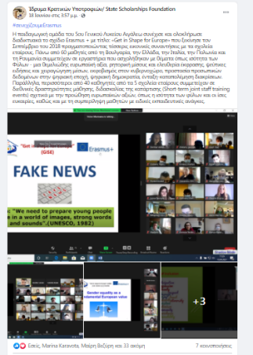
E. Activity 5: Our post on the fb of the State Scholarships Foundation was also posted on the personal fb of several teachers, on the GISE fb, on the West Side Culture fb, and on the fb “French Language in the southern Aegean” (nine notifications in all)

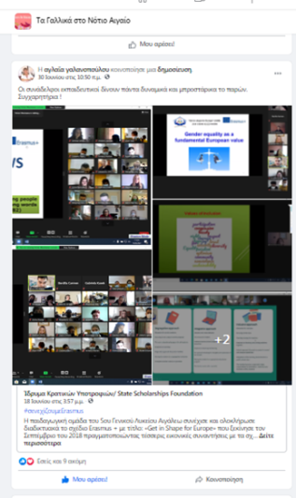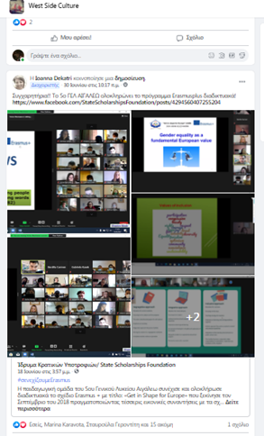
2. The Association of Parents and Guardians of Aigaleo fb
F.Activity 6: https://www.facebook.com/permalink.php?story_fbid=4324948867526653&id=960088534012720
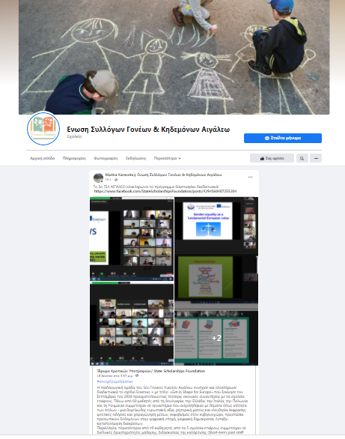

ΙΙ. Boards with photos in the school area
Activity 7: Boards with photos in the school area

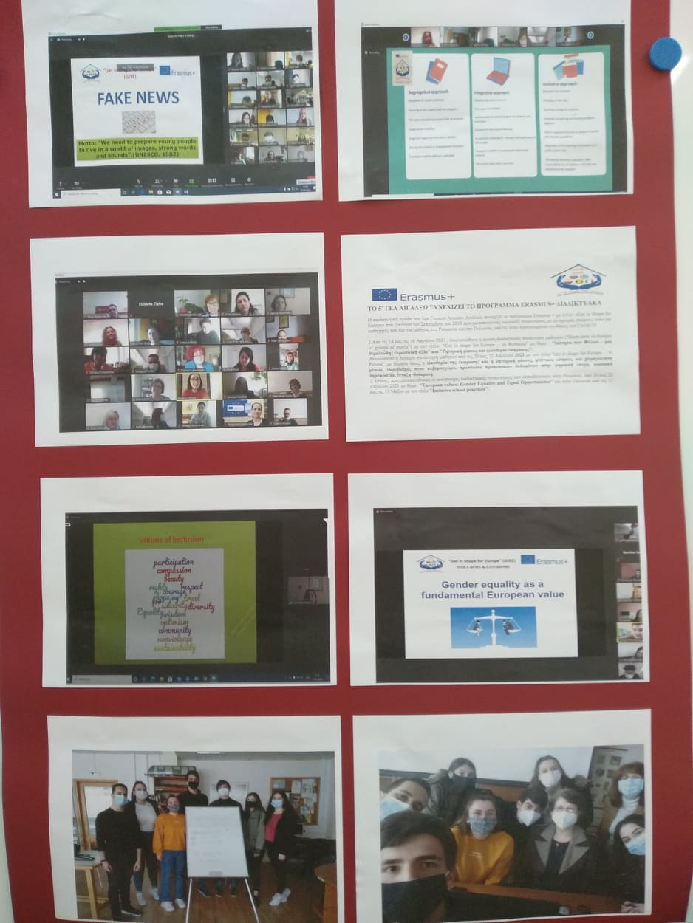

ΙΙΙ.The website of the Municipality of Aigaleo

https://www.aigaleo.gr/2021/07/16/to-5o-gel-aigaleo-synechizei-kai-oloklironei-to-programma-erasmus-diadiktyaka/

