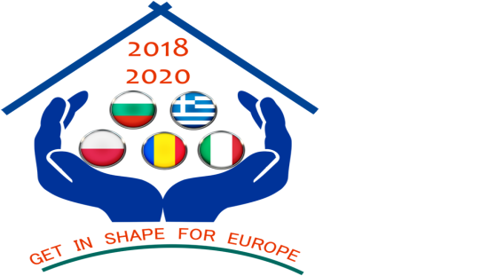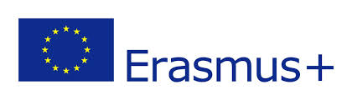

Partnership „Get in shape for Europe” (GISE)
Project number: 2018-1-RO01-KA229-049580
C5-Short-term joint staff training Events – ”Democratic Competences in the Digital Era”
Duration of the activity: 3 days: 05-07 November 2019 (excluding travelling days)
Host Institution: 5th General Senior High School of Aigaleo, Aigaleo, Greece

TEACHER REPORT FORM

- First and last name:

- School:

3. Email address:

4. Was this your first participation in a Short-term joint staff training Events?
DA NU

5.What were your main motivations for your participation in a Short-term joint staff training Events? (Multiple answers are possible)

To learn from good practice abroad, to learn new things | 18
To share good practice, my own knowledge and skills with other teachers regarding the design and implementation skills of learning activities that contribute to the development of social, civic and intercultural competences among pupils | 18
To improve my knowledge about European values | 18
To gain new skills and competencies regarding the design and implementation skills of learning activities that contribute to the development of social, civic and intercultural competences among pupils | 18
To exchange experiences and best practices on the implementation of European projects | 15
To enriched my competencies in designing the learning activities centered on the promotion of European values | 16
To develop my intercultural competences and a better understanding of cultural and linguistic diversity | 14
To develop civic and social skills | 18
To improve my communication skills in English | 12
To make new contacts | 13
To increase my job satisfaction | 18
Other (mention another motivation)
IMPORTANT! For questions 6, 7 and 8, you must also take into account the period before transnational activity (transnational activity preparation period).

6. As a consequence of my participation in this transnational activity, I have ….

 | Strongly agree | Rather agree | Neither agree nor disagree | Rather disagree | Strongly disagree
Improved my knowledge about manipulation through the media, the Internet, social networks, fake news, cyber bullying etc., about critical thinking and media education in my country and other European countries | 16 | 2
Improved my knowledge about culture and civilization of the host country | 17 | 1
Improving the design and implementation skills of learning activities that will contribute to the development of critical thinking in the use of Internet and social networks as a weapon against discrimination and manipulation | 14 | 4
Developed my team work abilities | 12 | 6
Developed my communication skills in English | 12 | 4 | 2
Improved my knowledge and skills regarding the design and implementation of European projects | 12 | 4 | 1 | 1
Become more motivated to carry on developing my professional skills | 13 | 5
Learn from examples of good practice | 16 | 2
Shared my own knowledge and skills with other teachers | 15 | 1 | 1 | 1
Been able to experiment and develop new learning practices an teaching methods | 14 | 2 | 2
Build up new contacts | 7 | 9 | 1
Improved my knowledge of education systems in other partner countries | 10 | 7 | 1
Improved my awareness of competences acquired in formal and informal learning context | 5 | 10 | 3
Improved emotional skills (e.g. having more self-confidence) | 11 | 7
Improved my practical skills (e.g. planning and organizing, project management etc.) | 11 | 5 | 2
Other

7. By participating in this transnational activity (Short-term joint staff training Events) I believe I have developed the following competences:

Key Competence¹ | Strongly agree | Rather agree | Neither agree nor disagree | Rather disagree | Strongly disagree
Literacy competence² | 6 | 10 | 2
Multilingual competence | 16 |  | 2
Mathematical competence and competence in science, technology and engineering | 4 | 5 | 7 | 1 | 2
Digital competence | 6 | 10 | 1 | 1
Personal, social and learning to learn competence | 13 | 4 |  | 1
Citizenship competence | 16 | 2
Entrepreneurship competence | 6 | 8 | 2 | 2
Cultural awareness and expression competence | 16 | 1 | 1

¹COUNCIL RECOMMENDATION of 22 May 2018 on key competences for lifelong learning
²Literacy is the ability to identify, understand, express, create, and interpret concepts, feelings, facts and opinions in both oral and written forms, using visual, sound/audio and digital materials across disciplines and contexts. It implies the ability to communicate and connect effectively with others, in an appropriate and creative way

8. I believe my participation in this transnational activity (Short-term joint staff training Events) will have the following impact on my school:

 | Strongly agree | Rather agree | Neither agree nor disagree | Rather disagree | Strongly disagree
Creating opportunities for me to share the knowledge acquired through my participation with colleagues | 15 | 2 | 1
Creating opportunities for the planning and development of new educational activities | 13 | 5
Reinforcing a positive attitude of my school towards European projects | 15 | 2 | 1
Improving the visibility of my school in educational community | 13 | 5
Strengthening the cooperation with the schools partners in this project | 17 |  | 1
Strengthening my school efforts to internationalize its activities | 17 |  | 1
Starting and joining new European/international projects | 12 | 4 | 2

9. How satisfied are you with your transnational activity (Short-term joint staff training Events)?
 | Satisfaction |  | 1 | 2 | 3 | 4 | 5
 |  | My general impression/satisfaction of this transnational activity is … |  |  |  | 5 | 13
Please write at least two strengths (positive aspects) of this transnational activity and at least two weaknesses (negative aspects). What was your favorite activity/work session? Why? Do you have suggestions for the next transnational activity?

POSITIVE ASPECTS:
-good organization of the activities by the host partner (2)
-communication and colaboration between partners; (2)
-the best practices shared by other partners;
-I improved my knoledge about the culture and the civilisation of the host country;
-interesting activities;
-good hospitality of the hosts towards all the participants; (4)
-delicious food, intersting workshops for the students; (4)
-Greek team do their best and we are satisfied by the work we have done; Greek collegues are very kind of us and they have organised all the activities in a perfect way; (4)
-the bonds of friendship and the ability of making friends;
-the meeting with Mr Moschos and the activity done with the students;
-the focus on the topics of the transnational activity; all the activities were centred on the topics;
-the great collaboration among the colleagues of the Greek team;
-the activities done were very engaging and focused on the topics;
-the presentation about fake news which was very informative and interesting;
-all the activities were very interesting and linked to the transnational activity theme;

NEGATIVE ASPECTS:
-none (8)
-overpacked agende – little free time; (4)
-no time to climb the Acropolis rock; (4)

MY FAVOURITE ACTIVITIES:
-”Real or Fake?” (2)
-”Democratic competences in the digital era” – practical aspect – the best practices shared by the other partners
”What your digital footprint?” (4)
-the activities with Ms Olga Gkotsopoulou and Mr George Moschos were great; I will proposed them to my students; (2)
-the journey to Delphi and the performance of the students with oracles and Pythis;

SUGGESTIONS:
-more free time; (2)

10. Would you like to participate in other transnational activity in the future?
YES or NO

NAME AND SIGNATURE

