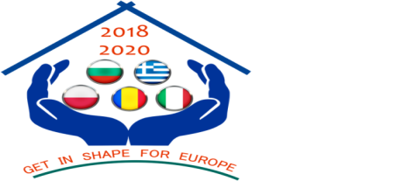
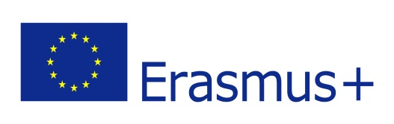

Project funded by the Erasmus+ Programme of the European Union
Partnership „Get in shape for Europe” (GISE)
C1-Short-term joint staff training Events - Teaching Common Values in Europe
25 February – 1 March 2019
Host institution: Foreign Language School (Pleven, Bulgaria)

Minutes no. 1

I. Participants
Name of partner organization | Country,  Town | Name of participants
Foreign Language Secondary School | Bulgaria  Pleven | Greta Dimova  Tanya Ilieva  Rumyana Stamenova  Zhorzheta Kamenopolska  Milena Marinova  Rozaliya Danova  Nela Zlatarska  Daniela Tsankova  Teodora Stefanova  Teodora Stefanova  Lyudmila Boyadzieva  Cvetoslava Mancheva  Nadezhda Valeva
The High School ”Stefan Procopiu” | Vaslui, Romania | Coșaru Georgiana  Luca Diana  Loghin Diana  Apopuțoaie Mihaela
5th General Senior High School of Aigaleo | Aigaleo, Greece | Papaiakovou Athanasios  Gkotsopoulos Panagiotis  Gerontiti Stavroula  Karavota Marina  Polyzoi Grigoritsa
The High School of Economics and Gastronomy | Tarnów, Poland | Malgorzata Krzeminska  Magdalena Borszowska  Katarzyna Curylo
I.I.S. E. Majorana-A. Cascino | Piazza Armerina, Enna, Italy | Arena Raffaella  Carbonaro Concetta  Casanova Armando  Colajanni Maria  Curcuraci Rosanna  Mariggiò Leonarda

II. Transnational activity description

Description of the activity:
Title: Teaching Common Values in Europe
Host partner: Foreign Language School (Pleven, Bulgaria)

Content and methodology
Goal of the activity: sharing best practices and experiences in developing students' social and civic competences by promoting common European values

Activities:

a) debates and presentations. Approached topics:
- a.1.Erasmus+ program-opportunities and challenges (to create the context in which the project is being developed)
- a.2.Teaching Common Values in Europe (European and national policies on the promotion of common values, Common values in national curriculum, the role of teachers in promoting common values among pupils, etc.)
- a.3. “My Europe – My Future – My Voice – My Vote” – presented by: Krasimira Vasileva, Doctor of Science, instructor at Sofia University’s Department of “European Science” and chairperson of the National Association of the Bulgarian European Clubs

b) a good practice seminar
- b.1.How can eTwinning contribute to the development of social, civic and intercultural competences and to promoting common values?)
- b.2.Presenting experiences and good practices on the development of social, civic and intercultural competences by promoting European common values and active citizenship.
- b.3. Peer activity: Three things I liked /I learned from the presentations made. Working in pairs (2 teachers from different countries), teachers discussed and identify 3 things they liked / learned from examples of experiences and good practice.

c) workshops, practical exercises and learning activities, debates and reflections in transnational mixed teams: learning activities that promote European values, using the workspace on the eTwinning platform, brochure work
- c.1. Group activity: the realization of lesson projects focused on topics related to European values
- c.2. using the workspace on the eTwinning platform
- c.3. brochure structure: discussions, suggestions (“Teaching Common values in Europe”)

d)reflection and evaluation exercises (comments and feedback, filling in questionnaires), granting mobility certificates)

e)Documentary visits and intercultural activities

III. Transnational activity results and benefits

RESULTS OF THE ACTIVITY
a)Intangible
- improved knowledge of European values, about the place of European values in curriculum in partner countries, about culture and civilization of partner countries, exchange of experiences and best practices on the implementation of European projects
- enriched competencies in designing the learning activities centred on the promotion of European values, developing intercultural competences and a better understanding of cultural and linguistic diversity, developing civic and social skills, improving communication skills in English
- positive attitude towards cultural and linguistic diversity, increasing motivation, positive attitude towards oneself and others
- developing the European dimension of partner schools by exchanging best practices among teachers, increasing the capacity of partner schools for transnational cooperation
b)Tangible: the brochure “Teaching Common values in Europe”

Benefits for participants:
- Increasing knowledge about common European values, culture and civilization of the host country;
- Improving the design and implementation skills of learning activities that contribute to the development of social, civic and intercultural competences among pupils by promoting common European values
- developing social and intercultural competences as these activities will offer the opportunity to work in mixed transnational teams, communicate constructively in an intercultural environment, show tolerance, express and understand different points of view, negotiate and to empathize.
- developing communication skills in English; the participants will also be able to get in touch with less-spoken languages at European level (Romanian, Polish, Bulgarian, Greek). Some people are shy when it comes to expressing themselves in a foreign language, and such an activity offers these people the opportunity to overcome such obstacles and to communicate with people from other countries, gaining self-confidence, becoming more motivated to make progress in this respect.
- improving knowledge and skills regarding the design and implementation of European projects. The major impact will be in the case of partners with little experience in this respect.
- developing motivation. Participants will develop different skills for becoming more self-confident, more trained and more motivated to engage in other activities and projects.

IV. Transnational activity evaluation
- Methods used to assess the activity: discussions, filling in questionnaires

V. Results validation
- Methods used to validate learning outcomes: Acquisition Certificates for each teacher participant signed by the sending school and also by the school that organized the transnational activity.
- Also, each participant received the Attendance Certificate.

