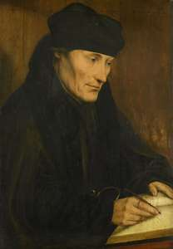
Who was Erasmus?
Erasmus,in full Desiderius Erasmus, (born October 27, 1469,Rotterdam, Holland-died July 12, 1536, Basel, Switzerland), Dutch humanist who was the greatest scholar of the northern Renaissance, the first editor of the New Testament, and an important figure in patristics and classical literature. He is considered one of the greatest scholars of the northern Renaissance.
Using the philological methods pioneered by Italian humanists, Erasmus helped lay the groundwork for the historical-critical study of the past, especially in his studies of the Greek New Testament and the Church Fathers. His educational writings contributed to the replacement of the older scholastic curriculum by the new humanist emphasis on the classics.
Early life
Erasmus rose from obscure beginnings to become one of the leading intellectual figures of the early Northern Renaissance. Most historians believe that he was born Gerard Gerardson in 1466 (with many noting his probable birthdate as October 27) in Rotterdam, Holland. His father, believed to be Roger Gerard, was a priest, and his mother was named Margaret, the daughter of a physician. He was christened with the name "Erasmus," meaning "beloved."

Erasmus began his education at the age of 4, attending a school in Gouda, a town near Rotterdam. When he was 9 years old, his father sent him to a prestigious Latin grammar school, where his natural academic ability blossomed. After his parents died in 1483 from the plague, Erasmus was put into the care of guardians, who were adamant about him becoming a monk. While he gained a personal relationship with God, he rejected the harsh rules and strict methods of the religious teachers of the time.

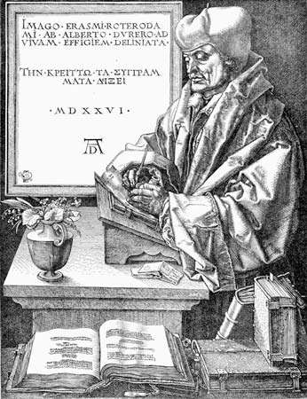
A Brief Stint in the Priesthood
In 1492, poverty forced Erasmus into monastery life, and he was ordained a Catholic priest, but it seems that he never actively worked as a cleric. There is some evidence, during this time, of a relationship with a fellow male student, but scholars are not in agreement as to its extent. Erasmus's life changed dramatically when he became secretary for Henry de Bergen, bishop of Chambray, who was impressed with his skill in Latin. The bishop enabled Erasmus to travel to Paris, France, to study classical literature and Latin, and it was there that he was introduced to Renaissance humanism.

Life as a Professional Scholar
While in Paris, Erasmus became known as an excellent scholar and lecturer. One of his pupils, William Blunt, Lord Montjoy, established a pension for Erasmus, allowing him to adopt a life of an independent scholar moving from city to city tutoring, lecturing and corresponding with some of the most brilliant thinkers of Europe. In 1499, he traveled to England and met Thomas More and John Colet, both of whom would have a great influence on him. Over the next 10 years, Erasmus divided his time between France, the Netherlands and England, writing some of his best works.

